Integral Methodology for Value Assessment of the 20th Century Architectural Heritage in Bosnia and Herzegovina
UDC (12pt italic, centered, spacing before 6 pt, spacing after 30 pt,
keep with next)

Lejla Kahrović Handžić¹ and Ana Nikezić²
¹Department of Theory and History of Architecture and the Preservation of Built Heritage, Faculty of Architecture, University of Sarajevo, Sarajevo, Bosnia and Herzegovina; PhD Candidate, Faculty of Architecture, University of Belgrade, Belgrade, Serbia
²Faculty of Architecture, University of Belgrade, Belgrade, Serbia.

Abstract. The legacy of the 20th century architecture in B&H is unrecognized as cultural heritage which results in great loses of important architectural work. An integral methodology was created with the intention to make the process of 20th century architectural heritage identification and value assessment in B&H systematic and context related. On one side, it is based on theoretical knowledge that is rooted in charters, documents, and declarations of international and regional background with a stress on authenticity and integrity of different criteria. While on the other hand, it is founded on the belief that analyses of architectural heritage has an equal representative potential and expertise visibility through graphical and descriptive form. Integral methodology was applied and demonstrated on the case study, the Crni vrh urban villa in Sarajevo, B&H. The results of the research are two folded: the first points out that the international set of criteria for value assessment is complete only when specificities of the regional context are added; the second one shows that the graphical and descriptive part of value analyses and assessment are equally important and valuable and therefore inherently necessary in the process of creating conservation recommendations for the 20th century architectural heritage.
Key words: 20th century architecture; integral methodology; value criteria; heritage identification, value assessment; urban villa; Bosnia and Herzegovina.
Abbreviations:
B&H – Bosnia and Herzegovina
WHL – World Heritage List
LNMB&H – List of National Monuments of Bosnia and Herzegovina
ICOMOS – International Council on Monuments and Sites
UNESCO – United Nations Educational, Science and Cultural Organisation
DOCOMOMO – International Committee for Documentation and Conservation of Buildings, Sites and Neighbourhoods of the Modern Movement
DOCOMOMO NWC – Docomomo National Working Chapter
COMMISSION - Commission for the Preservation of National Monuments of Bosnia and Herzegovina

INTRODUCTION
The 20th century architectural heritage is not systematically identified as heritage worldwide. It is not valued by institutions nor by society which leads to an inadequate protection and loses of authenticity and integrity. A global study ‘’The World Heritage List’’ (WHL) conducted by ICOMOS for UNESCO shows heritage of modernism as under-represented category. The study clearly emphasizes the insufficiently researched and inadequately methodologically set identification and evaluation of the legacy of modernism [1]. Until 1994, the architecture of Brasilia was the only example of modernism at WHL [2]. From 1994. until today the inclusion of modernism worldwide remains slow and lacks in identification and value assessment.
The 20th century is a long-time frame that includes numerous movements, styles and architectural expressions (see Fig. 1). But going through key organisations and its reports and studies when 20th century architecture protection is in question all recommendations refer to modernism or Modern movement [1] [2] [3]. When it comes to the legacy of the 20th century, the international perspective, recognizes the legacy of modernism as a revolutionary movement that opposes to the academic interpretation of architecture of historical styles. Even though Le Corbusier was a pioneer of brutalism and an architect who built key buildings of international style, his work was designated on the World Heritage List as ‘’Contribution to the Modern Movement’’. ‘’The inaugural use of Purism can be seen in the Maisons La Roche et Jeanneret, Cité Frugès and the Maison Guiette; the Unité d’Habitation played a pioneering role in promoting the trend of Brutalism, while the Chapelle Notre-Dame-du-Haut and the Capitol Complex promoted sculptural forms.’’ It was a legacy of wider range of movements and styles where 20th century architecture encompasses it all. [4] when we look at the Luis Barragán House and Studio located in Mexico City, it is presented as important regional adaptation of the Modern Movement. The house is designated through criterion (i): ‘’The House and Studio of Luis Barragán represent a masterpiece of the new developments in the Modern Movement, integrating traditional, philosophical and artistic currents into a new synthesis.’’ [5] On the other the work of Frank Lloyd Wright was inscribed as ‘’ The 20th Century Architecture of Frank Lloyd Wright’’ with additional description of his organic architecture. [6] It is important to emphasis 20th century architecture as synonym for all movements and styles in order not to put focus only on architecture of modernism and Modern Movement. It is important to highlight diversity of architecture of the 20th century and its adaptation through regional contexts that can be seen as additional value (see Fig. 1).

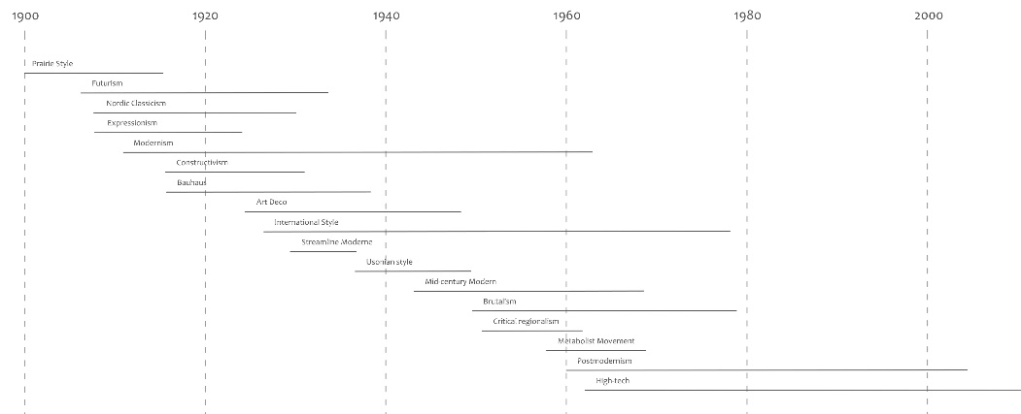
Fig. 1 Chronological presentation of architectural styles and movements of the 20th century. (Source: author)
During 20th century Bosnia and Herzegovina (B&H) was a part of Austro-Hungarian Monarchy, Kingdom of Yugoslavia, Democratic Federal Yugoslavia, Federal People's Republic of Yugoslavia, and Socialist Federal Republic of Yugoslavia [7]. As Kulić, Mrduljaš and Thaler state, Yugoslavia was a country of two letters, three languages, four religions, five nationalities, six constituent republics and seven neighbours [8]. When we look at the area of Sarajevo, capital city of B&H, there are numerous examples of unidentified, unrecognised and unassessed 20th century architecture. Through numerous problems, three key ones stand out. First one is absence of enlisted 20th century architectural heritage from the List of National Monuments of B&H (LNMB&H). The second problem lies in the lack of related criteria for recognizing and assessing heritage as the first step toward adequate preservation, i.e. the absence of an evaluation methodology focusing on regional 20th century heritage [9]. The third one is low level of public awareness and recognition. As a result of all tree problems, architectural heritage of the 20th century in B&H is losing its authenticity and integrity, it is vulnerable and in danger of disappearing.
Even though 20th century architectural heritage on the LNMB&H is short, one step towards positive promotion of 20th century architecture happened with introduction of the Docomomo BH and its establishment [10]. Until 2021 B&H did not have a Docomomo National Working Chapter (NWC) which is why international methodologies for the identification and evaluation of the heritage of the 20th century were not well applied, therefore, heritage lacked proper documentation and presentation.
The second problem related to criteria identification and value assessment is emphasized by absence of law on the protection and preservation of cultural and historical heritage at the state level, which is divided into the law of the Federation of B&H and Republic of Srpska. The absence of laws at the state level and the absence of political will to harmonize the system and methods of heritage protection results in a non-harmonized protection process [11]. Added to this, the Commission does not have established criteria and methodology for assessing the value of architectural heritage with a focus on the heritage of the 20th century. The absence of methodology resulted in an inadequate understanding and appreciation of the architecture and thus its failure to preserve it.
Then we look at the system of heritage protection in B&H it goes through several levels, and it is intertwined and overlapping which makes heritage protection even more difficult which contributes to the third problem of low level of public awareness and recognition. The jurisdictions of authorities are transferred from one to another, which results in non-protection of heritage. The system consists of cantonal and entity levels institutions for heritage protection and Commission to Preserve National Monuments of B&H (Commission) [9]. Analysis of current protection practice in B&H is well explained in the IRPP report [11]. Going through IPPR report one can conclude that B&H has no unified system of documentation, digitization, and archiving, which makes it difficult to exchange between protection institutions, and makes it difficult for the public to access information about heritage.
Therefore, the main objective of this research is to create a value assessment methodology that relates international and regional criteria, recognizes authenticity and identity of regional 20th century architecture and verifies it through visual analyses as to be publicly recognized and accepted.
One of the most significant research projects, which supports the need to recognize the architectural heritage of the 20th century, in area of former Yugoslavia, was realized by a group of authors led by Martino Stierli and Vladimir Kulić. Its importance lies in properties presentation as heritage and its acceptance by the professionals and wider public, The project entitled ‘’Toward a Concrete Utopia: Architecture in Yugoslavia, 1948–198’’ was a research project resulted in an exhibition and publication realized in the Museum of Modern Art in New York from June 15, 2018, until January 13, 2019 [12]. The magnitude of the impact of this exhibition was of great importance for raising awareness of the value of 20th century architecture and changing the view from architectural creativity to architectural heritage worth preserving. The importance of the exhibition is primarily reflected in the collected and presented material for its exceptional documentary value, and representational and promotional potential. This is one of the reasons for including graphical analysis as important element in formulating an integral methodology. The exhibition opened the door to the world of Yugoslav production and the important position it had in relation to the international architectural scene of the 20th century [13]. It was the result of cooperation of experts from all the Federal Republics of the former Yugoslavia. One of the experts on Yugoslavia architectural heritage is Maroje Mrduljaš, who documented and promoted numerous examples of architectural heritage of 20th century in Croatia. Through the series of documentary films ’’Betonski spavači’’ [Concrete Sleeper], he puts light on the forgotten and neglected socialist architecture, in the way that promotes and highlights its values. Films series, a visual form, was chosen as best for promotional purposes and for rising awareness of wider public while Maroje Mrduljaš explains descriptively all the values [14] [15]. This is why a visual component in value assessment and presentation is important and it will be key part in integral methodology.
Appreciation of 20th century architecture is gradually increasing in some regions, however many fine and extensive sites from this period are still threatened by a general lack of awareness and recognition. Too often they are under the pressure of changes or simply neglected and left to the negative influence of time. 20th century heritage on NLMB&H is very short and it shows the relationship between the doctrine of protection and the political system [9]. Even the National Monuments of B&H continue to deteriorate, there are no protection studies, the buildings and complexes are not treated or protected. The only thing that stands very shyly and barely visible is the mandatory sign with the monument's designation. It is evident that currently the only protection of the heritage of the 20th century is raising the awareness of citizens and users of those spaces about their values. On the other hand, the lack of detailed documents, guidelines and instructions on the methodology of identification and evaluation of the 20th century architecture and its application in B&H are an obstacle that can be overcome by research and scientific contribution. This is why integral methodology was formulated in order to facilitate easier identification and value assessment of 20th century architecture as heritage for Commission and wider public.
The article consists of two parts. The first deals with structuring the integral methodology through international and regional criteria framework, and the second demonstrates and apply integral methodology value assessment on the Crni vrh villa in Sarajevo. The results shows that the international framework of criteria for value assessment can be expanded with specificities of the regional context and that graphical and descriptive part of value analyses are important, valuable and necessary.

Materials and Methods
The development of research was carried out through four steps. First one was the analysis of international framework through theoretical background for 20th century architecture, on one side, and on the other through charters, documents, declarations, and organizations for 20th century architectural heritage. Second step was the analysis of regional background, focusing on regional specific values and Commission’s value assessment methodology. The third step was sublimation of first two through integral methodology formation. The end step was the development of visual assessment criteria through the visual analysis of Crni vrh villa. This was carried out through the division of graphical and descriptive criteria using architectural desin analysis tools adopted from the 20th century architectural theory agenda. Throughout the work combined research methods were applied: from inductive and deductive, comparative, historical, genetic methods, methods of analysis and synthesis, generalization and specialization, classification, description, and case study [16].
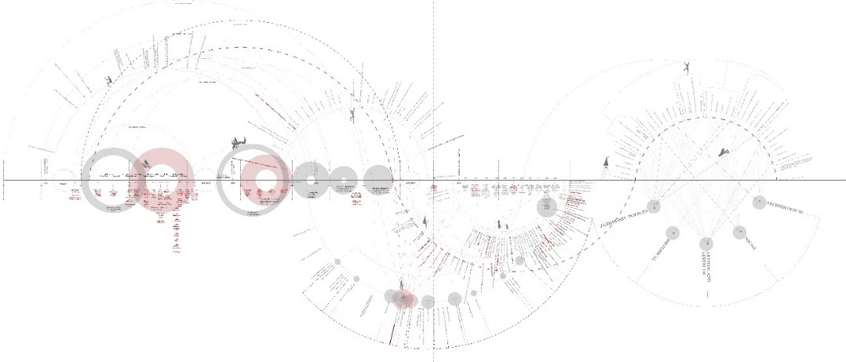
Fig. 2 Chronological matrix of the research. (Source: author)
The process of research is shown through Chronological matrix of the research (see Fig. 2). The matrix of the research has to be read from left to right following the chronological line divided into decades. Looking at the whole, the left part refers to the period of the 20th century, and the right part to the 21st century. Also looking at the whole, the matrix is divided into three parts. The first part refers to the development and construction of Sarajevo and the literature that follows the construction of buildings in the 20th century. This part of the literature is slowly moving into the central part of the matrix, which is located on the lower side of the chronological line and represents the focus of the current monitoring of the international background and evaluation criteria. The outer semicircle represents the development of international charters, documents, and declarations, where the most important documents are highlighted with dot accents. The year 1990 represents a change in thinking about the doctrine of protection towards the protection of the heritage of the 20th century. The two smaller semicircles closer to the right third of the matrix represent 20th century monuments on the WHL and NLMB&H. The third part of the matrix, formed on both sides of the chronological line, represents division of the previously researched criteria into five basic Docomomo categories as key 20th century architecture value categories [17].
The analysis of research papers in the field of practical application of methodologies for identification and value assessment of the heritage of the 20th century resulted in a very small number [18], as well as papers dealing with the presentation of the practical application of methodologies in the process of protection of important works [19] which is why it is of great importance to rase awareness through scientific research. The same conclusion was reached by Jelica Jovanović. In the introductory part, Jovanović emphasizes the inadequacy of existing methodologies that should be improved, completely reformulated, or created new ones. In her work, she uses two methodologies: Docomomo and the Brno/Vienna Methodology. Janković developed a methodology for scoring objects, where she assigned a score list to each criteria. On the basis of the total assigned value criteria and their sum of points, the most valuable objects are highlighted [20]. This type of approach was educational in the service of creating an integral methodology for value assessment of 20th century architecture in B&H.

International perspective
In order to form integral methodology, the first step was identification of the value criteria of 20th century through the analysis of charters, documents, and declarations of international organizations such as UNESCO, ICOMOS, Docomomo and Council of Europe.
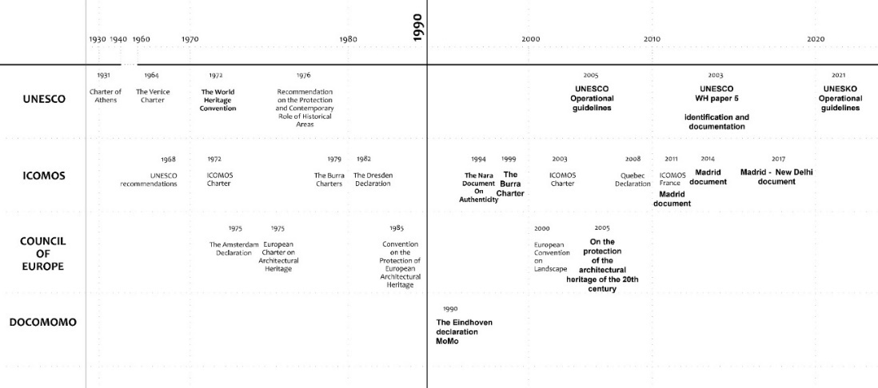
Fig. 3 Overview of publications by international organization for heritage protection from 1930 to the present day. (Source: author)
The most important documents were the World Heritage papers 5 [3], the Convention on the Protection of Cultural and Natural Heritage [21], and the WHL that was established for the inclusion of properties of Outstanding Universal Value. World Heritage papers 5 states in Annex B that the process of preserving the heritage consists of two phases: (a) research, documentation, construction of a database, defining critical issues of protection, preservation and raising public awareness; (b) identification of potential world heritage sites and establishment of regionally harmonized tentative lists. This document explicitly explained that all categories of 20th century heritage must be investigated and that databases must be established. The main conclusion of World Heritage papers 5 is that the relevant criteria for the evaluation, identification, and preservation of the heritage of modernism must be specially designed for each geo-cultural region in the world [3] as it is also well explained in Nara charter [22]. This is why the focus of this research is on first step towards protection of architectural heritage of 20th century in B&H, the identification and value assessment. Going through Fig. 3 one can see that ICOMOS has published several important documents: for preservation of architectural heritage such as The Burra Charter [23] and for preservation of 20th century heritage The Madrid Document [24] [25] [26]. In these documents all criteria for value assessment of architectural heritage of 20th century were selected for integral methodology framework. One of the most important ICOMOS documents is Burra Charter [27] [28] [23]. Its importance lies in graphical explication of identification, evaluation and preservation process of architectural heritage shown through Burra Charter Diagram [23]. The first part of diagram clearly shows importance of identification and value assessment prior protection of architectural heritage which is why integral methodology was formulated. In 2004 ICOMOS established ICOMOS for 20th Century Heritage (ISC20C) focusing only on 20th century architecture [29]. Because of lack of related criteria for value assessment, i.e., the absence of an evaluation methodology it is important to create integral methodology within Commission’s methodology as separate branch focusing only on 20th century architecture.
It is important to point out that Docomomo, as international organization focusing on architecture of Modern Movement, founded at a conference in Eindhoven in 1990 [30], represents a key international organization with NWC established worldwide. This is why all value criteria found through Docomomo NWC were selected for adequate establishment of integral methodology.
Another document that sublimates key recommendations on protection of 20th century architecture and selections of value criteria, Council of Europe convention ‘’On the protection of the architectural heritage of the 20th century’’ was consulted [31]. An overview of the publications of the key organizations UNESCO, ICOMOS, Docomomo and Council of Europe showed that they uniformly make efforts to promote 20th century heritage, methodologies, and principles of protection as well as to spread awareness of the wider public (see Fig 3).
According to the overview of previous organisations, documents, charters, and declarations, criteria for identification of architectural of 20th century heritage and value assessment were selected for creating the overall framework of criteria for integral methodology.
The focus pointed put through literature review was on importance of identification of potential heritage sites and establishment of regionally harmonized tentative lists. The second point was on research, documentation and raising public awareness. It is important to state that most of the materials dealing with the protection of 20th century architecture highlights its under-representation in World and National Lists of Monuments. International organisations have published key documents that sublimates recommendations on identification, value assessment and protection of 20th century architecture. At last, it has to be concluded that Docomomo as worldwide organisation with NWCs have great power to shine light on neglected and unprotected heritage with all its regional specificities.

Regional perspective
When we look from the regional perspective the most important document is "Regulations on evaluation criteria". This is the methodological document that Commission uses for heritage inscription of properties as national monuments [32]. Analysis of differences between methodology from 2002 and 2019 showed the use of the same criteria but grouped into different categories [33] [32](see Fig. 4). The analysis of the decisions on the declaration of the property as a national monument showed shift of the focus on authenticity and integrity with the definition of authenticity and integrity by a certain attribute. But the attributes of authenticity and integrity are not defined in this document [32]. It can be concluded from the analysis of LNMB&H documentation that attributes of authenticity are taken from Article 82 of the UNESCO Operational Guidelines for the Implementation of the World Heritage Convention. In the analysis of the degree of integrity, the attributes of completeness, physical wholeness, compactness are mentioned, as well as social-functional and visual integrity, which are not precisely listed and described in more detail in the methodology. Therefore, it is not entirely clear, based on which attributes, the Commission decides on the degree of integrity. These methodologies were used as base to create an integral methodology for 20th century architectural heritage identification and value assessment in B&H.
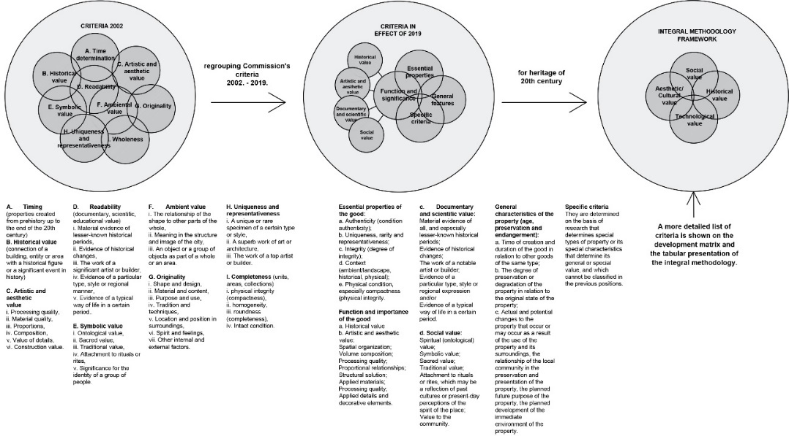
Fig. 4 Graphic representation of differences between Regulations on evaluation criteria from 2002 and 2019 and defining the framework for an integral valuation methodology. (Source: authors)
The key category for value assessment of the 20th century architecture are defined by the Docomomo identification methodology and evaluation criteria summarized in the ‘’Docomomo fishe’’ report [17]. The main goal of Docomomo fiche is to create forms that will be used globally in a unified manner. These forms should represent scientific contributions to the research and promotion of the 20th century heritage [34]. The fourth part of the report refers to the evaluation through five key value criteria - technical, social, cultural/aesthetic, historical value, and general assessment - general evaluation of the value of the property [17]. To date, 79 countries are involved in the work of the Docomomo organization as NWC that promote and protect the architecture of the MoMo at individual national levels [35]. Going through numerous NWC web sites and NWC publications one can conclude that not all NWC have an equally detailed identification and assessment of the architecture of the MoMo. Some NWC have a more detailed description of evaluation by criteria, while others have only a list of objects without additional description and presentation of evaluation even though Docomomo advocates usage of specific identification and evaluation methodology formulated in fiche.
When we look at the Docomomo BH during its first year of operation, a total of 30 Docomomo fiche forms were filled out as a condition for full membership in Docomomo International [36]. Within the 30 fiches, there are four urban villas (villas Kopcic, Bajlon, Cvitkovic and Perinovic) which were filled in by the author of this research. The Archive of Modern Architecture of B&H was also established and the project of creating a ‘’Guide to Modern Architecture of B&H 1918-85’’ was initiated, where two urban villas were selected to be published [37].
First, currently used methodology for value assessment and heritage inscription in B&H is unsystematic and poorly defined. It has unclear use of authenticity and integrity attributes. On the other side NWC Docomomo BH has only five categories of values criteria while context related architecture is so much more complexed. In order to protect entire range of architectural expressions of 20th century architecture in B&H it is important to state that regional context brings diversity to original architectural movements of 20th century and therefore adds to its layers of values. At last, it has to be concluded that this kind of perspective towards diversity of architectural styles of 20th century will protect wider range of heritage.

Integral Methodology
Integral methodology is defined in the correlation between international and regional perspectives. The term integral refers to the inclusion of all parts in the whole rather than separate isolation; also refers to the term of having all the parts that are necessary for the purpose of wholeness. Which is why the term integral methodology refers to the sublimation of existing evaluation methodologies and criteria of various international and regional organizations and institutions for the purpose of creating an overall methodology that includes all aspects of the evaluation of an architectural work.
The chronological review of international perspective presented above was conducted to collect all criteria for identification and value assessment of architectural work of 20th century. It resulted in the identification of criteria from the historical, through aesthetic, cultural, social, and architectural to scientific, artistic, technological, economic value and the significance of places or landscapes. The evaluation criteria for 20th century heritage found through international perspective represent a united front. This unification can be clearly seen through same or similar evaluation criteria that are emphasized in all the documents [34] [24] [25] [26] [31] [38].
Regional perspective was applied through the analysis of inscription process in B&H [33] [32], and through analysis of national monuments of B&H which have been treated with protection measures through various projects led by Commission [39]. The key criteria found through regional perspective were specific proportion, form and volume (characteristic for Ottoman architecture realized through ‘’doxat’’ architecture and continuous windows); value of architectural detail (specific use of material and construction); specific regional type, style or manner; transposition of vernacular elements through contemporary principles; evidence of characteristic lifestyle in specific time period.

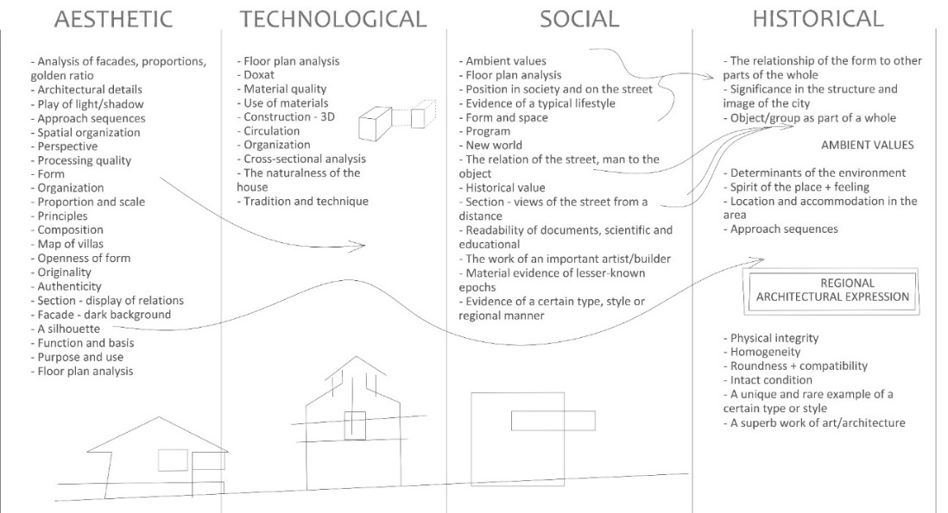
Fig. 5 Division of criteria into four categories: aesthetic, technological, social and historical. (Source: authors)
At the end comparative analysis of found criteria in international charters, documents, and declarations, UNESCO, ICOMOS and Commission methodologies were sorted through categories of Docomomo methodology (see Fig. 5). The notion of 20th century architecture questioned through these key aesthetic, technological, social, and historical criteria categories presented by Docomomo facilitates simple and globally uniformed identification and values assessment of the heritage of the 20th century [17] [40].
For the structuring of integral methodology for B&H, five Docomomo categories were regrouped into four. Docomomo fifth category, general assessment, was assessed as redundant. All criteria found through international and regional framework such as new construction, new processing, new materials were sublimated under the technological category; testimony of a typical way of life in a certain period of time, significance for the identity of a group of people were sublimated under the social category; the values of form, design, proportions, content, details, function and use, the relationship of form to other parts of the whole, belonging to a certain style or regional manner, the value of a superior artistic or architectural work were sublimated under the aesthetic/cultural category; a testimony of historical changes, a masterpiece of a builder, a unique or rare example of a certain type or style were sublimated under the historical category (see Fig. 5). Ambient value, meaning of the object in the image of the city, object or group of objects as part of a whole or area, location and setting in place, uniqueness and representativeness, completeness (whole, areas, collections), physical integrity (compactness), homogeneity, completeness, roundness and intactness the conditions of the object were criteria found through international and regional background under the category of general assessment. These criteria needed to be sorted since category general assessment was estimated to be unnecessary. To do this, comparative analysis of all found criteria had to be done, after which four new categories were formulated: architectural, technological, ambiental value and value of the period (see Fig. 6).
The aesthetic category implied the analysis of architectural elements and the form of the architectural structure, which is why the name was changed to the architectural category. The architectural category refers to aesthetic, architectural and typological value criteria. Parallel to this, the additional literature was used to analyse the ways and models of specific graphic representation of certain elements [41] [42] [43] [44] [45] [46] [47] [48]. The social and historical categories are regrouped into two new categories, value of the period and ambient value. Third category was named ‘’value of the period’’ to emphasizes the importance of identifying architecture of the 20th century as heritage. All criteria ranging from social dimension, historical, to cultural are grouped under the category of value of the period. The previous historical and social criteria are now partly under the category of value of the period and partly under ambiental value. The ambiental value category was created due to a series of criteria related to context and environment.
Based on these analysis, integral methodology framework was defined with all criteria to be used in further research. Value criteria presented in Fig. 6 are further elaborated through explication of the specific partition between criteria and its origin.
The Commission’s criteria sublimated under architectural criteria are: proportions, value of architectural detail, composition, originality of form and design, originality of use and function, evidence of specific type, style and regional manner, colour schemes [32]; Docomomo’s and ICOMOS BiH’s criteria is: typological innovations [17] [40] [41]; Ching’s criteria are: analysis of the facade - golden ratio, architectural principles, silhouette of the building/villa/city, analysis of the facade on a dark background [42]; Milenkovic’s criteria are: analysis of floor plan and section, focal points and movements [43]; Rowe and Slutzky’s criteria is: play of light and shadow as an architectural detail [44]; the Neidhart and Grabrijan’s criteria are: concept, transposition of vernacular/traditional elements [45]; the Arnheim’s criteria are: analysis of architectural form, volume [46].
The Commission’s criteria sublimated under the technological category are: quality and originality of processing, value and originality of construction, symbolic value of tradition and construction techniques, quality and originality of materials [32]; Docomomo’s and ICOMOS BiH criteria is: constructive innovations [17] [40] [41]; Ching’s criteria is: cross-sectional analysis [42]; Milenkovic’s criteria is: the nature of the villa – the physics of the building [43]; and added criteria of “doxat” analysis as a technological innovation, cause and effect relationships between new construction and different organization of space, technical equipment.
The Commission’s criteria grouped under the value of the period category are: material evidence of a lesser-known historical period, evidence of historical changes, evidence of a characteristic lifestyle in a specific time period, unique, representative, and unique/rare example of a certain type or style, superior work of art or architecture, master work of an artist or builder, work of a famous architect/builder [32]; Docomomo’s and ICOMOS BiH’s criteria are: canonical value, influence on other works and architects, social innovations shown through changes to the building (floor plan, facade), or new innovative architecture promotes social changes, connection of the building with a historical event or personality [17] [40] [41]; Ching’s criteria is: relationship of plan-section-social dimensions [42]; and criteria of interior, associated furniture and works of art;
The Commission’s criteria grouped under the ambient value are: relation of shape and form to other parts of the whole and the street, meaning in the structure and image of the city, object or group of objects as a part of the whole, originality of the location and settings on the place, spirit of the place and feeling, completeness/physical integrity/compactness /homogeneity, roundness, intactness of the original state (integrity-units, locations, zones) [32]; Schulz’s criteria is: connection with greenery, yard and environment [47]; Ching’s criteria is: silhouette of villas/city [42]; Neidhart and Grabrijan’s criteria is: belonging to the region – regional architectural expression [45]; and added criteria approach sequences, relationship of detail/form to the environment, analysis of position on the site, narrower and wider position, space boundaries, terrain morphology, altitude, climate, orientation, traffic, and infrastructure.
All criteria found through analysis of regional context and history of B&H resulted in added criteria shown in green, which were not found through analysis of international and regional frameworks (see Fig. 6).

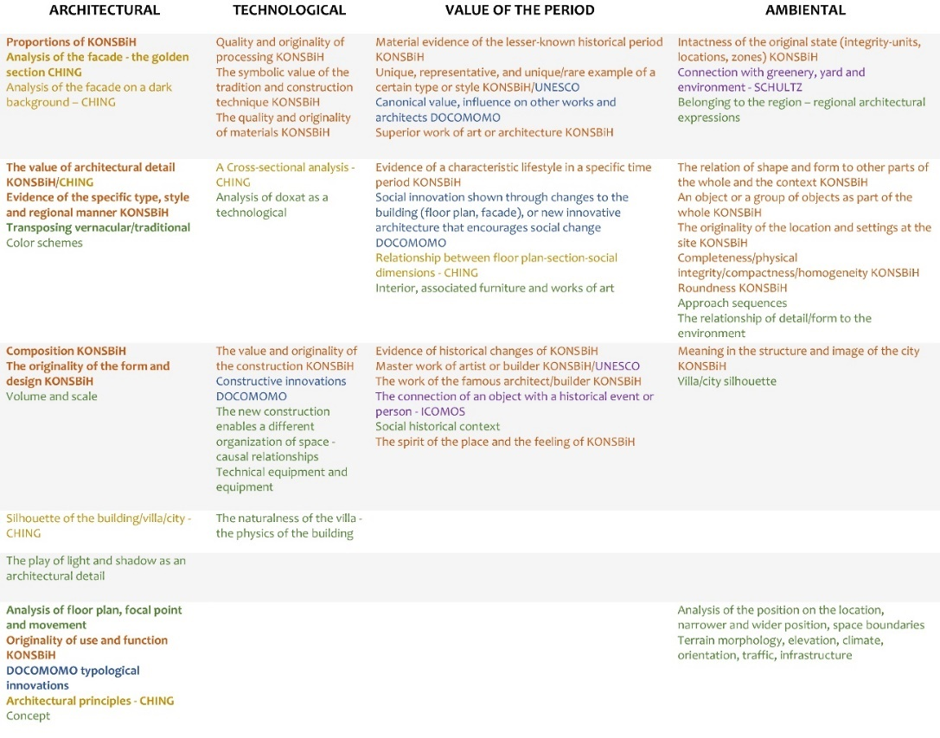
Fig. 6 The division of criteria into four categories: architectural, technological, ambiental value, and value of the period. Criteria in orange colour are regional criteria. (Source: authors)

Graphical value assessment
Generally accepted form of heritage assessment is descriptive one. On the account of the experience gained from various regional projects dealing with recognition and presentation of 20th century heritage, visual presentation and graphical analysis are outlined as important when value assessment is in question [19]. All displayed criteria were tested for graphical presentation. The research is based on the argument that the graphical elements are representational, readable, and self-explicable. It is easier and faster to see rather than to read in order to present to profession and wider public all values that establishes 20th century architecture’s eligibility for protection. However, all criteria for value assessment are impossible and unnecessary to present graphically which is why they were divided into graphical and descriptive ones. The scheme for reading graphical elements is presented in Fig. 7.

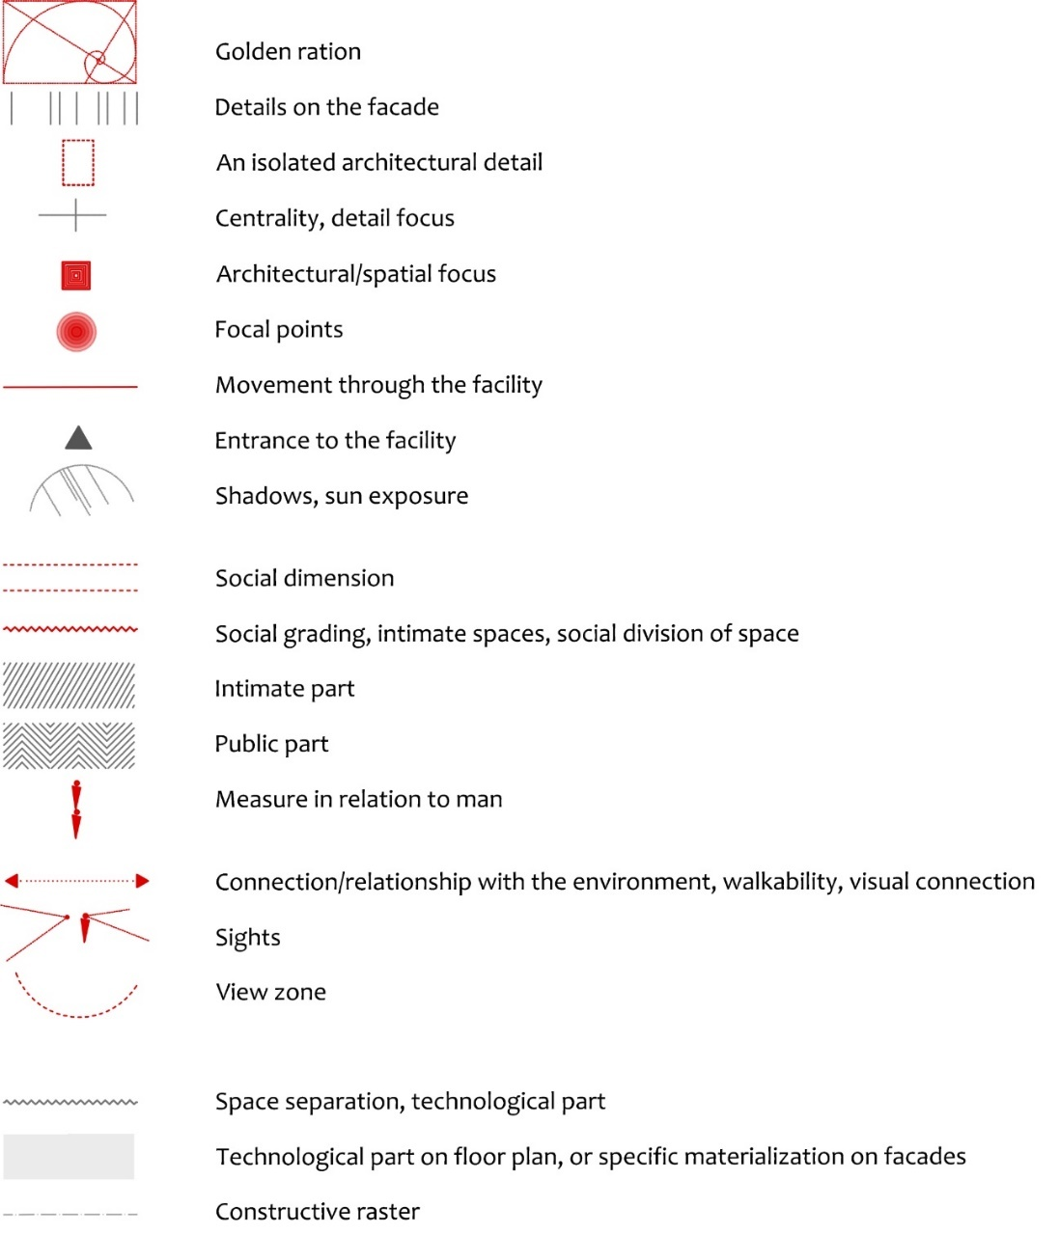
Fig. 7 List of graphical value assessment tools. (Source: authors)
To test graphical representation of value criteria formulated in integral methodology urban villa form Sarajevo region was selected. This typology was fertile soil on which architects cloud show new progressive thoughts, free of political and social inputs. It was selected for case study as best one for easiest representation of 20th century architecture identification and value assessment through graphic and descriptive method. The urban villas of the 20th century in B&H represent a legacy that is not viewed exclusively negatively, as was the case with the destruction of memorial complexes, monuments, and parks. When we look at the entire oeuvre of architectural heritage of the 20th century in B&H, this attitude is characteristic for monumental, public facilities and residential complexes of collective housing which contributes to the non-identification and undervaluation of this heritage. On the other hand, when we look at the LNMB&H, the paradox is that the most represented monuments are precisely those that have been destroyed and are currently deteriorating the most. Out of a total of 903 decisions, there are 32 decisions on national monuments created in the period of the 20th century, of which 16 decisions are memorial complexes, monuments, and parks. The institutional protection of the architectural heritage of the 20th century in B&H began in 2002 with the registration of the first building of the AVNOJ House in Jajce. Currently, there are 12 urban villas from Crni vrh settlement under one decision [9]. When we look at the opus of urban villas of Sarajevo today, some of the most significant examples of international and/or regional expression have completely lost their authenticity. This primarily refers to the irreversible changes that completely damaged the authenticity and integrity of Crni vrh villas. Which is why the selected case study was precisely one of the urban villas from this settlement.

Demonstration and application of integral methodology – descriptive and graphical part
Sarajevo is a city formed down the slopes of the surrounding hills and in a valley with a strong Ottoman and Austro-Hungarian heritage visible throughout the city as factors of its regional specificity. On the map individual residential buildings are represented, first from the Ottoman period in green colour (large houses, complexes - equivalent to today's concept of urban villas) (see Fig. 9) [49]. Austro-Hungarian villas are the most represented category focused in the central part of the city (represented in blue colour) [50]. The dashed red line represents the metaphorical border of East and West, that is, the line of demarcation between Ottoman and Austro-Hungarian architecture, which is still clearly visible through the city today.
Villas of the Bosnian style, as a specific regional architectural expression, were occasionally introduced in the dense urban fabric of the Austro-Hungarian matrix (represented in orange colour). The Bosnian style is a combination of Austro-Hungarian and Ottoman elements of architecture [51]. Its volume belongs to the architecture of the Austro-Hungarian period, which is why it is located in the central area of the city, in the continuation of the Austro-Hungarian blocks and rows of buildings, with details of Ottoman architecture.
Urban villas of the 20th century were mostly scattered throughout Sarajevo (represented in red colour), but there are four larger groups (red circles). When we look at the map from west to east, the first grouping clearly stands out in the area of Crni vrh, with large number of urban villas, precisely because it is a settlement that is divided into parcels for 93 individual residential buildings (urban villas according to the 1937 plan) [52] (see Fig. 9). The second group of buildings are located in the Kosevo-Gabelina zone and the third in the Tina Ujevica-Pruscakova zone. At the same time, they represent the zones of Austro-Hungarian architecture, which is why the buildings are adapted and volume-wise fit into the mentioned environment. Urban villas in the above-mentioned zones are distinct representatives of modernism. The mentioned zones are located in the central and western part of the city, on the left side of the east-west boundary line. On the other side, there is the fourth focal point of the construction of urban villas located in Safet-beg Basagica street. The villas were created as interpolations of new modernist principles in an environment with a strong genius loci of the Ottoman mahala. These villas, located on the right side of the east-west boundary line, are representatives of the regional architectural expression. What is an unusual phenomenon are the two villas at the top of the Crni vrh settlement, built in the spirit of regional architectural expression in a zone that does not have the ambiental characteristics of the traditional architecture it refers to (see Fig. 9, red square). One of these villas was selected for case study.

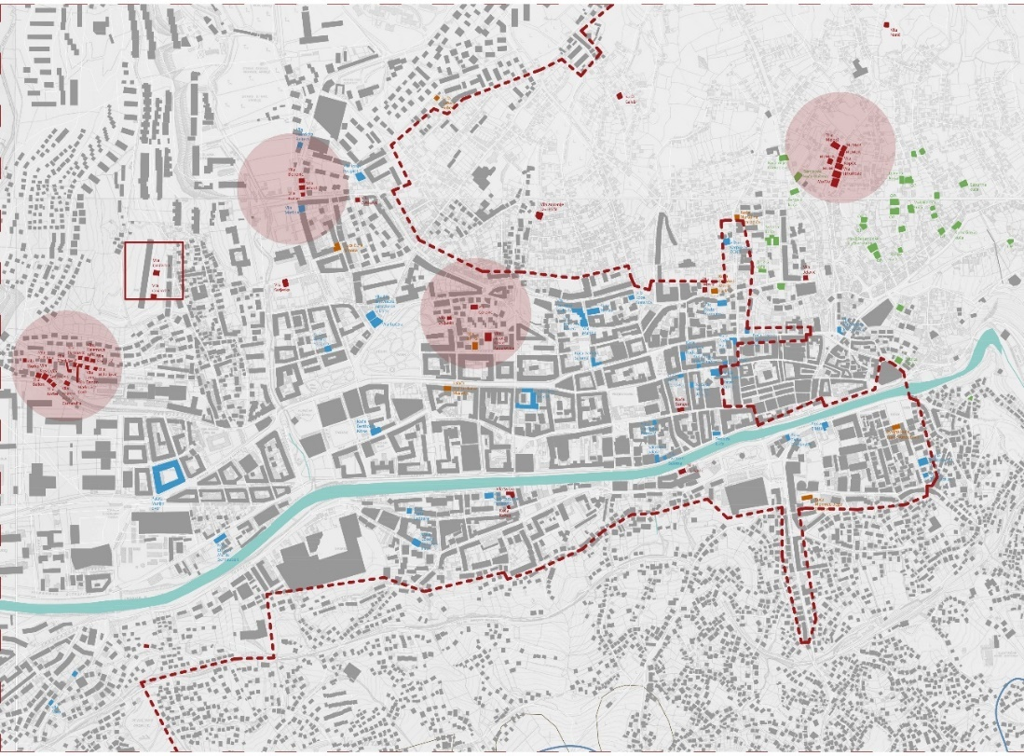
Fig. 9 Mapping of residential complexes of the Ottoman period (green colour), Austro-Hungarian (blue colour), Bosnian style villas (orange colour) and 20th century urban villas (red colour), (Source: authors, background plan: Digital ground plan of Sarajevo "Site Plan & Figure Ground Plan of Sarajevo for download as PDF, DXF Plan, 1:100 000", SCHWARZPLAN.EU, downloaded on November 22, 2021, from: https ://schwarzplan.eu/en/figure-ground-plan-site-plan-sarajevo/)
The practice of demolishing highly valuable examples of architectural heritage in Sarajevo is visible in the example of the urban villas of Crni Vrh, the only planned settlement built in the spirit of modernism from the period between the two world wars. The regulatory plan from 1932 had foreseen 93 plots for individual housing [52]. Most of the plan has been implemented. At the highest altitude of this settlement, there were two separate urban villas. They represented valuable examples of regional architectural expression created in the middle of the 20th century which were partially destroyed by war destruction from 1992-1995. Unfortunately, today these villas have been demolished in order to build new complex of five high-rise residential buildings [53] [54] (see Fig. 8). This is classical example of gentrification where city territories are lost due to neoliberal spatial city planning [55].

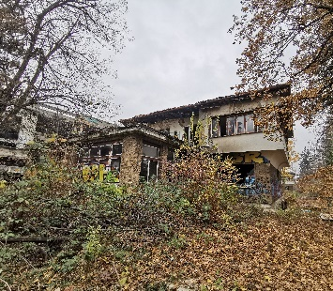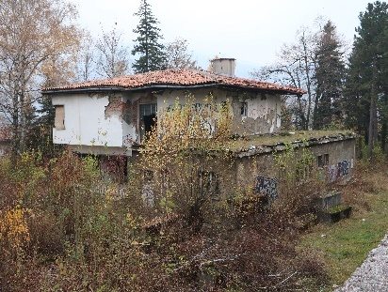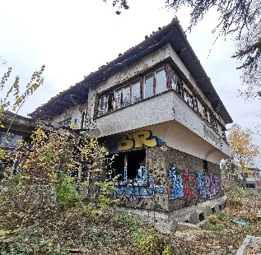
- (b) (c)
Fig. 8 (a)(b)(c) Condition before demolition of Crni vrh urban villa. (Source: author’s archive, 2020)
After regrouping the criteria into four major categories (see Fig. 6), all criteria were analysed individually. For this purpose, the Crni vrh urban villa was selected as the best example of a modernist villa with elements of regional architectural expression. The analysis included a graphic presentation of the individual criteria selected in the previous research. Since there is no information about the architect of the villa, the year of construction, or the name of the villa, it was necessary to record the villa in detail in situ. ‘’Documentation, which comes first in DOCMOMO's acronym, is often the best means of conservation.’’ [56]
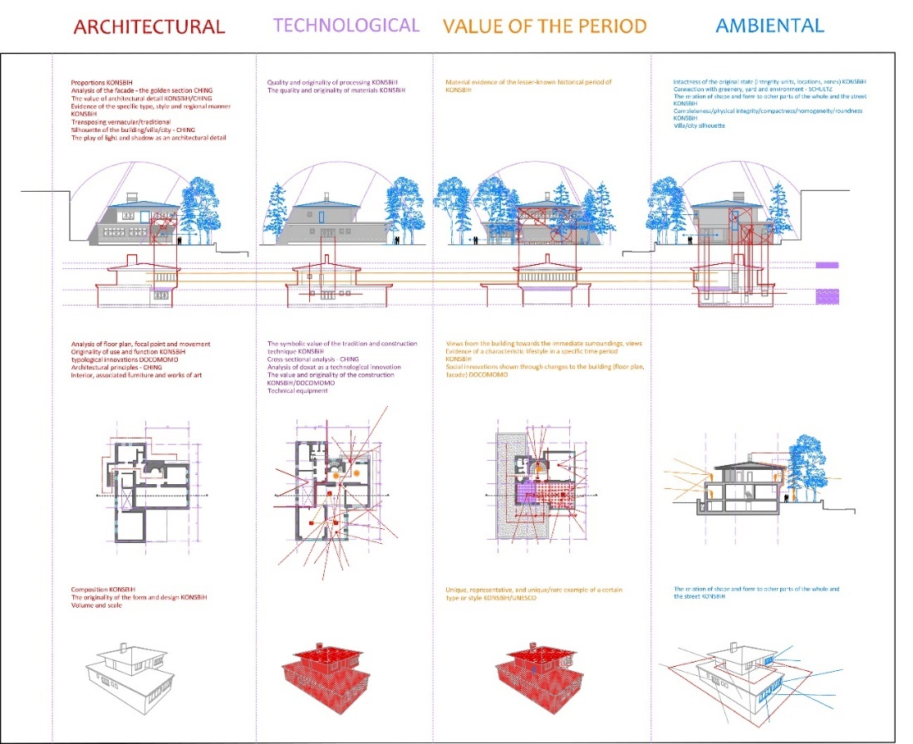
Fig. 10 Application of criteria presented in Fig. 6 on the example of the Crni vrh urban villa - graphic value assessment. (Source: authors)
For the purpose of the research case study villa was named Crni vrh urban villa. After documenting and drawing the villa, graphic evaluation followed. The first step towards graphic evaluation was the tabular presentation of each criterion graphically for one category. Proportion and golden ration were analysed through facades, as well as value of architectural detail, elements of specific style or regional manner shown through transposing vernacular elements, silhouette, and use of light and shadows as architectural detail (see Fig. 10). All these elements can be graphically presented on the façade or scheme that emphasise the details. Under the facades, schemes through simplified manner connect all facades and show silhouette, details, proportions, asymmetry and form. Through floor plan and section focal point and movement are analysed, but also typological innovations and architectural principles. Through 3D view composition, form, volume, scale and design were analysed. All the criteria were analysed in search of values that are important to protect under architectural category.
On the façade it is possible to analyse quality and originally of façade finishings, use of materials, use of traditional construction techniques, analyses of doxat (prominent part of the first floor that goes over the ground floor as dominant part and important architectural detail of Ottoman architecture) all under technological category.
Criteria such as material evidence of the lesser-known historical period use by Commission can be seen through facades, views from the building towards immediate surroundings, elements of characteristic lifestyle in specific time period, social innovations shown through changes to the building and unique, rare example of certain type or style can be shown through floor plan, section and facades all under value of the period. This category was named value of the period as it was important to shine light on this period as valuable one.
At the end intactness of the original state, integrity, connection with greenery, (where Yugoslav architectural practice nurtured certain characteristics of biophilic concept [57]) completeness, homogeneity, roundness, relation of the shape and form to other part of the whole and to the context are criteria analysed through façade, floor plan and section, and 3D under ambiental value.
All presented criteria are formulated within integral methodology (see Fig. 11) with extra criteria that are descriptive ones such as spirit of the place and the feeling, evidence of a characteristic lifestyle in a specific time period, canonical value, influence on other works and architects, superior work of art or architecture, evidence of historical changes, master work of artist or builder, work of the famous architect/builder, connection of an object with a historical event or personality, social historical context.
After the graphical presentation of all criteria of all four categories (Architectural, Technical, Ambiental value and Value of the period), criteria were grouped according to the principle of similarity of graphic presentation. In this way, the criteria were combined according to the graphic category of presentation (Façade, Layout - floor plan and section, 3D, Urban situation) where it is possible to display several value criteria of different categories. Colour layers were used to separate the criteria by category. The test of graphic evaluation of the villa Crni vrh resulted in the selection of criteria that can be adequately displayed graphically (Fig. 10).
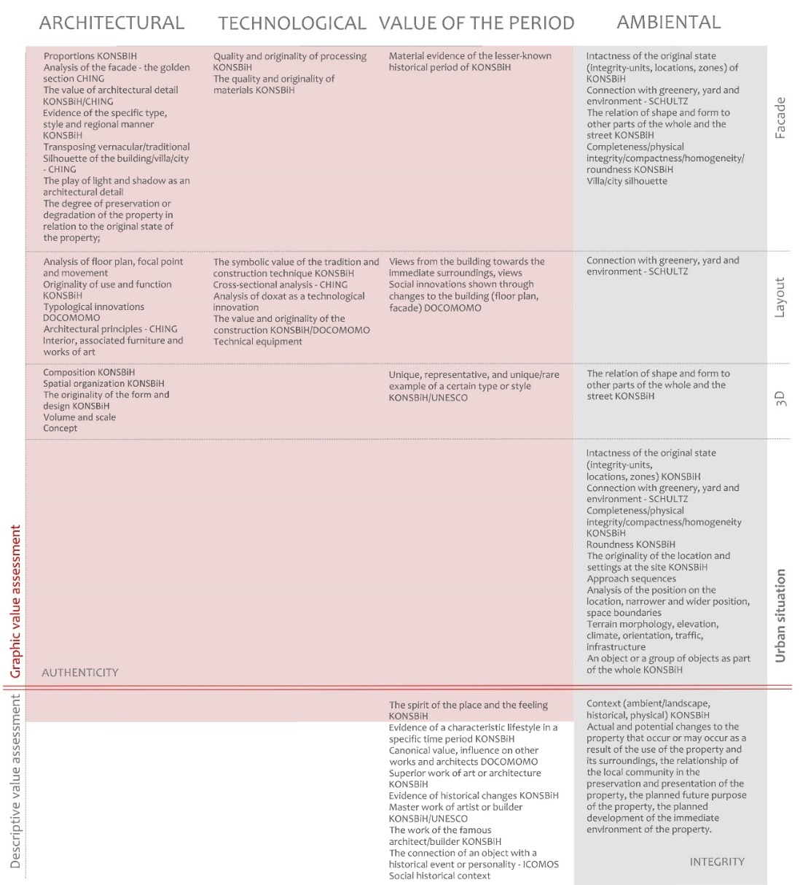
Fig. 11 Authenticity and integrity as part of the integral methodology of valuing the architectural heritage of the 20th century. (Source: authors)
The illustration shows on the upper side the applicable criteria in the graphic evaluation, while on the lower side it shows the criteria in the process of descriptive evaluation of the property (see Fig. 11). Part of the graphic evaluation is divided into four categories: architectural, technological, ambiental value, and value of the period, with a division into four graphic types of representation through facades, floor plans and sections, three-dimensional visualization, and urban transformation.
The results of this research showed that international set of criteria for value assessment with specificities of the regional values can be sublimated through integral methodology. Furthermore, analyses of graphical and descriptive representation of values showed that they are equally important and valuable in the process of establishing 20th century architecture eligibility for protection.
At the end presentational catalog of the property has been designed in order to focus on properties values highlighted through graphical analysis. Integral methodology has been adapted to radial form positioned in the lower central part of the catalog where grey criteria refers to integrity and red to authenticity. On the left side, catalog starts with urban transformation of the wider area and continues to the tridimensional presentation of property with additional descriptive information in between. At the top central and right part of the catalog floor plans, section and facades are presented through graphical value assessment. At the lower right part of the catalog descriptive information about integrity and authenticity has been presented as well as additional information about the property. This type of heritage presentation is important to spread awareness of wider public on architectural legacy that surrounds them. In most cases, the general public and the users are the ones who actively work, participate and contribute to the promotion and protection of architectural heritage (see Fig. 12). When this is not the case, and heritage stays unidentified and unassessed, we are losing great architectural works such as urban villa Crni vrh.

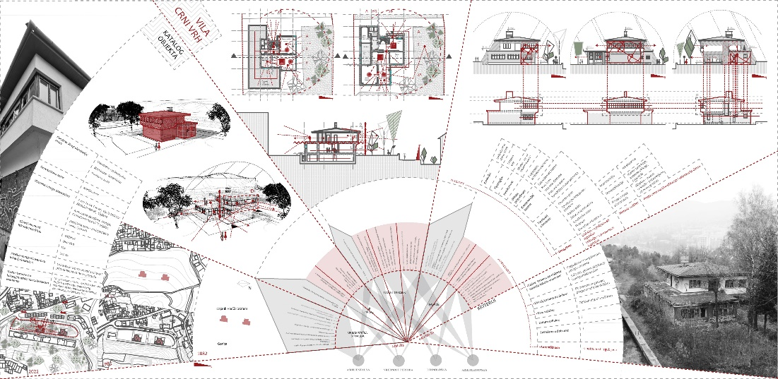
Fig. 12 Catalog of the urban villa Crni vrh, an adapted form of integral methodology for the purpose of graphical presentation of values and for wider promotional potential. (Source: authors)

Conclusion remarks
The goal of the research was to identify the value criteria for 20th century architecture assessment through a chronological international and regional literature review with a focus on currently important and relevant criteria in its preservation. From all the above, the graphical analysis pointed out the possibility of reduction and clear inclusion of a set of criteria for the assessment of architectural values. It succeeded in the architectural category which is main graphical representation point. It partially succeeded in the technological, value of the period and ambiental category. The descriptive part outlines the historical, social and context related values through ambiental and value of the period category. Each criterion proposed in the integral methodology can still be presented only descriptively, but graphical representation adds promotional values and visibility (see Fig. 12). In conclusion the systematic observation through graphical and descriptive part is necessary to adequately highlight all value aspects of the 20th century architectural heritage. Especially since it can be seen through the research that the authenticity and integrity of the 20th century architectural heritage are based on visual elements. Research of the concepts of authenticity and integrity and their application in practice during the evaluation of the property, according to the principles of the Nara document, is seen as a dynamic process [58]. To make this process of evaluation of the property and authenticity and integrity testing systematic and simpler the tabular working form was created, i.e., integral methodology. The tabular representation of the methodology primarily aims to emphasize the most important value criteria, the degree of authenticity, and integrity of each criterion in a concise and transparent form. Through this methodology the authenticity can be tested through architectural, technological category, authenticity and integrity can be tested through value of the period category, and the degree of integrity can be tested through ambiental category.
Value assessment through integral methodology demonstrated on the example of Crni vrh villa pointed out that combination of international and regional framework, illuminates more clearly the complexity of the architectural expression and the specificities of cultural patterns of the heritage. While graphical presentation shows the possibility of application and ways of integrating inherited elements into the contemporary framework of architectural practice (see Fig. 12). Integral methodology through its descriptive and graphical part has been created in order to shine light on values of the 20th century architecture and to spread awareness of the wider public.
Acknowledgement. To Branka Dimitrijevic, professor at Strathclyde University, Faculty of Architecture for mentoring the first phase of the research. This research was conducted in period of three months from 1 August until 31 October 2019. during which corresponding author did her introductory PhD research.

References
(Samples for Serial, Book, Proceeding, Thesis, Patent - Style Reference)

[1] | ICOMOS, "The World Heritage List," UNESCO, 2004.
[2] | UNESCO, "World Heritage List," UNESCO, 2023. [Online]. Available: https://whc.unesco.org/en/list/. [Accessed 20 March 2023].
[3] | UNESCO, "Annex B - Research and documentation programme," in World Heritage papers 5 - Identification and Documentation of Modern Heritage, Paris, UNESCO World Heritage Centre, Netherlands Funds-in-Trust, 2003.
[4] | UNESCO, "The Architectural Work of Le Corbusier, an Outstanding Contribution to the Modern Movement," UNESCO World Heritage List, 2016. [Online]. Available: https://whc.unesco.org/en/list/1321. [Accessed 30 March 2023].
[5] | UNESCO, "Luis Barragán House and Studio," UNESCO World Heritage List, 2004. [Online]. Available: https://whc.unesco.org/en/list/1136. [Accessed 30 March 2023].
[6] | UNESCO, "The 20th-Century Architecture of Frank Lloyd Wright," UNESCO World Heritage List, 2019. [Online]. Available: https://whc.unesco.org/en/list/1496. [Accessed 30 March 2023].
[7] | R. Donia, Sarajevo: biografija grada. [Sarajevo: biography of the city], Sarajevo: Institute of History, 2006.
[8] | V. Kulić, M. Mrduljaš and W. Thaler, Modernism In-Between - The Mediatory Architecture of Socialist Yugoslavia, Berlin: Jovis Verlag GmbH, 2012.
[9] | Commission, "Lista nacionalnih spomenika BiH. [List of national monuments of B&H]," Commission for the Preservation of National Monuments of B&H, 2023. [Online]. Available: http://aplikacija.kons.gov.ba/kons/public/nacionalnispomenici. [Accessed 20 January 2023].
[10] | Docomomo BH, "About," AABH, 2021. [Online]. Available: https://aabh.ba/o-namadocomomobh/. [Accessed 25 January 2023].
[11] | European Commission and Council of Europe, "Plan projekta integrisane rehabilitacije/Procene arhitektonskog i arheološkog nasleđa (IRPP/SAAH). [Integrated rehabilitation project plan/Assessment of architectural and archaeological heritage]," European Commission and Council of Europe, 2010.
[12] | M. Stierli, V. Kulić, T. Bjažić Klarin, V. Deskov, A. Herscher, S. Horvatinčić and T. Issaias, Toward a Concrete Utopia: Architecture in Yugoslavia, 1948–1980, New York: The Museum of Modern Art, 2018.
[13] | L. Slavkovic, Međunarodni forum: STVARANJE KONKRETNE UTOPIJE ARHITEKTURA JUGOSLAVIJE 1948-1980. [International forum: CREATION OF CONCRETE UTOPIA - ARCHITECTURE OF YUGOSLAVIA 1948-1980.], Beograd: CZKD, 2018.
[14] | G. Mrđen, Director, Betonski spavači. [Concrete sleepers]. [Film]. Hrvatska: Hulahop.d.o.o. . TV HRT1. Season 1., 2016.
[15] | G. Mrđen, Director, Betonski spavači. [Concrete sleepers]. [Film]. Hrvatska: Hulahop.d.o.o. TV HRT1. Season 2., 2019.
[16] | R. Zelenika, Metodologija i tehnologija izrade znanstvenog i stručnog djela [Methodology and technology of creating a scientific and professional work], Rijeka: Faculty of Economics, University of Rijeka, 2000.
[17] | Docomomo New Zealand, "Fiche and Guidelines," Docomomo New Zealand, 2022. [Online]. Available: https://www.docomomo.org.nz/register/fiche-and-guidelines/. [Accessed 13 December 2022].
[18] | A. Dragutinovic and A. Nikezic, "Unforeseen Impulses of Modernism: The Case of New Belgrade Blocks," in 100 YEARS BAUHAUS: What interest do we take in Modern Movement today?, U. Pottgiesser, F. Jaschke and M. Melenhorst, Eds., DOCOMOMO Deutschland e.V and TH OWL (OWL University of Applied Sciences), 2020, pp. 32-45. DOI: 10.25644/J4D2-6227
[19] | A. Čaušević, A. Idrizbegović Zgonić, N. Rustempašić and L. Kahrović Handžić, "A Case Study Restoration of Historical Museum in Sarajevo (1963) - A Modernist Ruin," International Journal of Heritage Architecture, vol. 2, no. 1, p. 138 – 148, 2018. DOI: 10.2495/HA-V2-N1-138-148
[20] | J. Janković, "Nove metodologije valorizacije modernističkog stanovanja druge polovine 20. veka – Primer Centralne zone Novog Beograda. [New methodologies for the valorization of modernist housing of the second half of the 20th century - An example of the Central Zone," in Arhitektura i urbanizam posle Drugog svetskog rata – zaštita kao proces ili model, [Architecture and urban planning after the Second World War - protection as a process or model], Belgrade, Institute for the Protection of Cultural Monuments of the City of Belgrade, 2015, pp. 54-69.
[21] | UNESCO, "The World Heritage Convention," 1972. [Online]. Available: https://whc.unesco.org/en/convention. [Accessed 15 December 2023].
[22] | Agency for Cultural Affairs (Government of Japan), UNESCO, ICCROM and ICOMOS, The Nara Document on Authenticity, M. Lemaire and M. Stovel, Eds., Nara: Agency for Cultural Affairs (Government of Japan), UNESCO, ICCROM and ICOMOS, 1994.
[23] | Australia ICOMOS, The Burra Charter, The Australia ICOMOS Charter for Places of Cultural Significance, Australia ICOMOS Inc. International Council of Monuments and Sites, 2013.
[24] | ICOMOS ISC20C, "Madrid Document, Approaches for the Conservation of Twentieth-Century Architectural Heritage," in 17th ICOMOS General Assembly, Madrid, 2011.
[25] | ICOMOS ISC20C, "Madrid Document, Approaches for the Conservation of Twentieth-Century Architectural Heritage," in 18th ICOMOS General Assembly, Florence:, 2014.
[26] | ICOMOS ISC20C, "Madrid - New Delhi Document, Approaches for the Conservation of Twentieth-Century Cultural Heritage," in 19th ICOMOS General Assembly, Delhi:, 2017.
[27] | Australia ICOMOS, The Burra Charter, Burra:: Australia ICOMOS, 1979.
[28] | Australia ICOMOS, The Burra Charter, Burra:: Australia ICOMOS, 1999.
[29] | S. Burke, "ICOMOS Twentieth Century Heritage International Scientific Committee," in Conservation of Modern Architecture, United Kingdom, Donhead Publishing, 2007.
[30] | H.-J. Henket and W. de Jonge, DOCOMOMO: First international conference, Eindhoven: DoCoMoMo international conference, 1990.
[31] | Council of Europe Committee of Ministers, O zaštiti arhitektonskog naslijeđa 20. stoljeća [On the protection of the architectural heritage of the 20th century], Kotor,: Council of Europe Committee of Ministers, Kotor, EXPEDITIO – center for sustainable spatial development, 1991.
[32] | Commission , Pravilnik o kriterijima vrednovanja, podeli i kategorizaciji nacionalnih spomenika.’’ [Regulations on evaluation criteria, division and categorization of national monuments], Sarajevo : Commission for the Preservation of National Monuments of B&H, 2019.
[33] | Commission, Kriteriji za donošenje odluke za proglašenje nacionalnog spomenika.’’ [Criteria for making a decision to declare a national monument], Sarajevo: Commission for the Preservation of National Monuments of B&H, 2002.
[34] | Docomomo International, "About," Do.co.mo.mo International, 2023. [Online]. Available: https://docomomo.com/organization/. [Accessed 18 January 2023].
[35] | D. International, "Chapters," Do.co.mo.mo International, 2022. [Online]. Available: https://docomomo.com/chapters/. [Accessed 18 January 2023].
[36] | Docomomo BH, "Naši projekti [Our projects]," AABH, 2023. [Online]. Available: https://aabh.ba/kategorija/docomomobh/nasi-projekti/. [Accessed 27 March 2023].
[37] | Docomomo BH, "Vodič za modernu arhitekturu Bosne i Hercegovine 1918-1985," AABH, 2022. [Online]. Available: https://aabh.ba/vodic-za-modernu-arhitekturu-bosne-i-hercegovine-1918-1985-guide-to-modern-architecture-of-bosnia-and-herzegovina-1918-1985/. [Accessed 25 March 2023].
[38] | UNESCO, "Operational Guidelines for the Implementation of the World Heritage Convention," 2019. [Online]. Available: https://whc.unesco.org/en/guidelines/. [Accessed 25 mARCH 2023].
[39] | Commission, Baština [Heritage], Sarajevo: Commission for the Preservation of National Monuments of B&H, 2008.
[40] | Docomomo US, "How to evaluate modern," Do.co.mo.mo US, 2023. [Online]. Available: https://www.docomomo-us.org/explore-modern/explore-the-register/how-to-evaluate-modern. [Accessed 27 March 2023].
[41] | ICOMOS BiH, "Arhitektura 20. stoljeća u BiH. [Architecture of the 20th century in B&H]," ICOMOS BiH, Sarajevo, 2018.
[42] | F. Ching, Architecture: Forme, Space and Order, USA: John Wiley&Sons, Inc., 2007.
[43] | B. Milenković, Uvod u arhitektonsku analizu. [Introduction to architectural analysis], Beograd: Građevinska knjiga d.o.o., 2009.
[44] | C. Rowe and S. Robert , Transparency, Basel, Boston, Berlin: Birkhauser Verlag, 1997.
[45] | J. Neidhart and D. Grabrijan, rhitektura Bosne i put u savremeno. [Architecture of Bosnia and the way to modernity], Ljubljana: Državna založba Slovenije, 1957.
[46] | R. Arnheim, Dinamika arhitektonske forme. [Dynamics of architectural form], Beograd: Univerzitet umetnosti u Beogradu, 1990.
[47] | C. N. Schulz, Principles of Modern architecture, London: Andreas Papadakis publisher, 2000.
[48] | M. Petrović, "Design and functional characteristics of the multi-family housing architecture in the period of mature and late modernarchitecture of niš - case studies," FACTA UNIVERSITATIS , Architecture and Civil Engineering, vol. 18, no. 2, pp. 177-193, 202. DOI: https://doi.org/10.2298/FUACE200927013P
[49] | L. Šabić and L. Kahrović Handžić, "Development of Urban Residential Zones of Sarajevo During the Ottoman Period from 1455-1604," in 6th World Multidisciplinary Civil Engineering-Architecture-Urban Planning Symposium, Prag, 2022.
[50] | B. Spasojević, Arhitektura stambenih palata austrougarskog perioda u Sarajevu, Sarajevo: SVJETLOST. OOUR Zavod za udžbenike i nastavna sredstva, 1988.
[51] | N. Kurto, Arhitektura Bosne i Hercegovine; razvoj bosanskog sloga. [Architecture of B&H; the development of the Bosnian syllable], Sarajevo: Sarajevo - Publishing Međunarodni centar za mir., 1998.
[52] | Commission, Građevinska celina – Stambeno naselje Crni Vrh u Sarajevu. [Building complex - Residential settlement Crni Vrh in Sarajevo], Sarajevo: Commission for the Preservation of National Monuments of B&H, 2012.
[53] | City Council Canton Sarajevo, Odluka o izmenama i dopunama regulacionog plana ‘’Gradski park Crni vrh’’. [Decision on changes and additions to the regulatory plan ‘’Crni vrh city park’’]., Sarajevo: Official newspaper of Sarajevo Canton, 2001.
[54] | City Council Canton Sarajevo, Odluka o usvajanju izmena i dopuna regulacionog plana ‘’Gradski park Crni vrh’’ - Zona rezidencijalnog stanovanja. [Decision on the adoption of amendments and additions to the regulatory plan’’City Park Crni vrh’’ - Zone of residential housing], Sarajevo: Official newspaper of Sarajevo , 2019.
[55] | V. Kostić, A. Kostić and M. Din, "Gentrification, creative class and problems of conflict of interest in contemporary urban development," FACTA UNIVERSITATIS Series: Architecture and Civil Engineering, vol. 16, no. 3, pp. 401-413, 2018. DOI: 10.2298/FUACE180524017K
[56] | D. Whitham, "Docomomo fourth international conference," International Journal of Heritage Studies, vol. 3, no. 2, pp. 116-117, 1997. DOI: 10.1080/13527259708722195
[57] | D. Stankovic, A. Cvetanovic, A. Rancic, V. Nikolic and B. Stankovic, "Biophilia in modern architectural practice: recommendations for Serbia," FACTA UNIVERSITATIS Series: Architecture and Civil Engineering, vol. 17, no. 2, pp. 133-143, 2019. DOI: https://doi.org/10.2298/FUACE190316007S
[58] | H. Stovel, "Authenticity in Conservation Decision-making: The World Heritage Perspective," Journal of Research in Architecture and Planning, vol. 3, pp. 1-8, 2004.

INTEGRALNA METODOLOGIJA vrednovanja ARHITEKTONSKOG NASLEĐA 20. veka U BOSNI I HERCEGOVINI

Nasleđe arhitekture 20. veka u BiH je neprepoznato kao kulturno nasleđe što rezultira velikim gubicima važnih arhitektonskih dela. Integralna metodologija je formirana sa namerom da se proces identifikacije i procene vrednosti graditeljskog nasleđa 20. veka u BiH učini sistematičnim i kontekstualnim. S jedne strane, integralna metodologija se zasniva na teorijskom znanju koje je ukorenjeno u poveljama, dokumentima i deklaracijama međunarodnog i regionalnog porekla s naglaskom na autentičnost i integritet različitih kriterija. Dok se sa druge strane, zasniva na uvjerenju da analiza graditeljskog nasleđa ima jednak reprezentativni potencijal i stručnu vidljivost i kroz grafičku i deskriptivnu formu. Integralna metodologija je primijenjena i demonstrirana kroz studiju slučaja urbane vile Crni vrh u Sarajevu, BiH. Rezultati istraživanja su dvojaki: prvi ističe da je međunarodni set kriterijuma za procenu vrednosti potpun samo kada se dodaju specifičnosti regionalnog konteksta; drugi pokazuje da su grafički i deskriptivni deo analize i procene vrednosti podjednako važni i vredni, a samim tim i inherentno neophodni u procesu kreiranja konzervatorskih preporuka za arhitektonsko nasleđe 20. veka.

Ključne reči: arhitektura 20. veka; integralna metodologija; kriterijumi vrednosti; identifikacija nasleđa, procena vrednosti; urbana vila; Bosna i Hercegovina.

