Digital Model Predictive Control of the Three Tank System based on Laguerre functions ∗
UDC ()

Miodrag Spasić^{1,2}, Dragan Antić¹, Nikola Danković¹, Staniša Perić¹, Saša S. Nikolić¹
¹University of Niš, Faculty of Electronic Engineering, Department of Control Systems, Niš, Republic of Serbia
²Norwegian University of Science and Technology, Department of Engineering Cybernetics, Trondheim, Norway
Abstract. The application of the model predictive control (MPC) based on discrete-time Laguerre functions is presented in this paper. A nonlinear three-tank hydraulic system is used as an object to which the proposed algorithm is applied. The paper also presents the method of linearization of the nonlinear system, as well as the procedure for the controller design. For the verification of the proposed control method, digital simulations are performed using Matlab.
Key words: model predictive control, hydraulic system, linearization

1. Introduction
Model Predictive Control (MPC) is a control method that has many applications in the different fields of engineering. For a long time, it is in the interest of both engineering and academic circles. In a sence, it represents a further development of optimal control algorithms for linear systems developed in the 50s and 60s of the last century [1], [2]. MPC has traditionally been used to control a system with relatively slow dynamics, but recently, this method for the linear and nonlinear systems control has found application in the chemical, petroleum and other industries [3], [4], due to more efficient optimization formulations and the availability of computational power.
The main idea is to use a dynamical model and an optimization formulation to optimize the predicted future plant behavior, with future inputs as degrees of freedom in the optimization. The optimization is performed for a finite prediction horizon into the future but re-optimized at every time step (hence the alternative name Receding Horizon Control). While the optimal control action over a future time horizon is calculated, only the first control action is implemented before the calculations are repeated at the next sample instant. This feature distinguishes MPC from other optimal control algorithms whose control law is determined off-line, i.e. it is pre-calculated.
For the application of digital MPC, it is possible to use various models of the system, such as the impulse response model, the transfer function model, the state space model, etc. In this paper, the state space model is used, whose main advantage is an easy representation of the system with multiple inputs and multiple outputs.
To cope with the time needed for the calculation of the optimal control move, as well as the number of the parameters used for the fast calculations when the long horizon is used, different methods can be introduced within the traditional MPC algorithm. One of them is using orthogonal functions representations of the predicted control trajectories. This paper shows how Laguerre functions can be applied in this manner [7].
The system of three reservoirs is considered in this paper. The primary control problem for this system is to achieve the desired fluid level in each of the tanks and keep this level constant. The control of the levels in all three tanks is achieved by the pump control, which serves to supply fluid to the system, and by automatic opening and closing valves that provide desired fluid flow.
The paper is organized in the following way. Section 2 provides a detailed description of the system with three reservoirs. Section 3 describes a nonlinear model of the system, and the following, Section 4, shows the process of linearizing the model of the system. Section 5 explains the design and application of the digital MPC based on Laguerre functions, and in Section 6, the simulated results are given. Section 7 contains conclusions and remarks on further work.

2. the three-tank system
The three-tank system consists of three physically separated reservoirs that, at their bottom, have valves whose opening allows the water to flow out of the tank. All three tanks are of different shapes. The first reservoir, viewed from above, has a constant cross-section. The other two reservoirs are spherical and conical, so they have different cross sections, which create basic nonlinearities in the system. To fill the fluid in the first tank, a variable flow pump is used. Fluid, due to gravity, goes into the other two reservoirs, and the flow is regulated by opening and closing the aforementioned controlled valves. There is a fluid level meter in each tank. Below the third tank is an auxiliary tank used to collect the fluid that flows from the third tank so that the same fluid is reused for charging the first tank with the pump. The block diagram of the described system is given in Fig. 1.
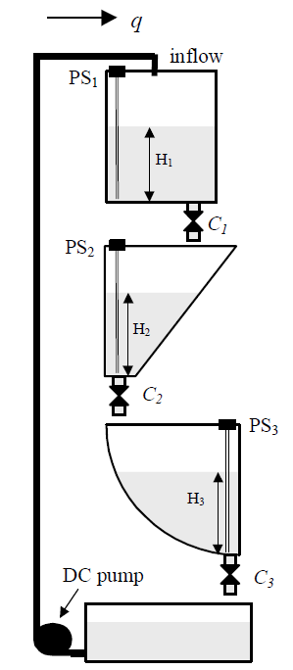

Fig. 1 The three-tank system
It is assumed that the valve-controlled system is considered, and the flow of the fluid, provided by the DC pump, is a constant parameter (Fig. 2).
The states of the system,, and represent the levels of the fluid in the first, second and third reservoirs, respectively.
The system is controlled by three inputs:
- - the control of the valve C1,
- - the control of the valve C2, and
- - the control of the valve C3.
The possibility of occurrence of fluctuations in fluid level control in reservoirs could be produced by nonlinearities due to reservoirs shape, valve geometry and dead zone of the valves.
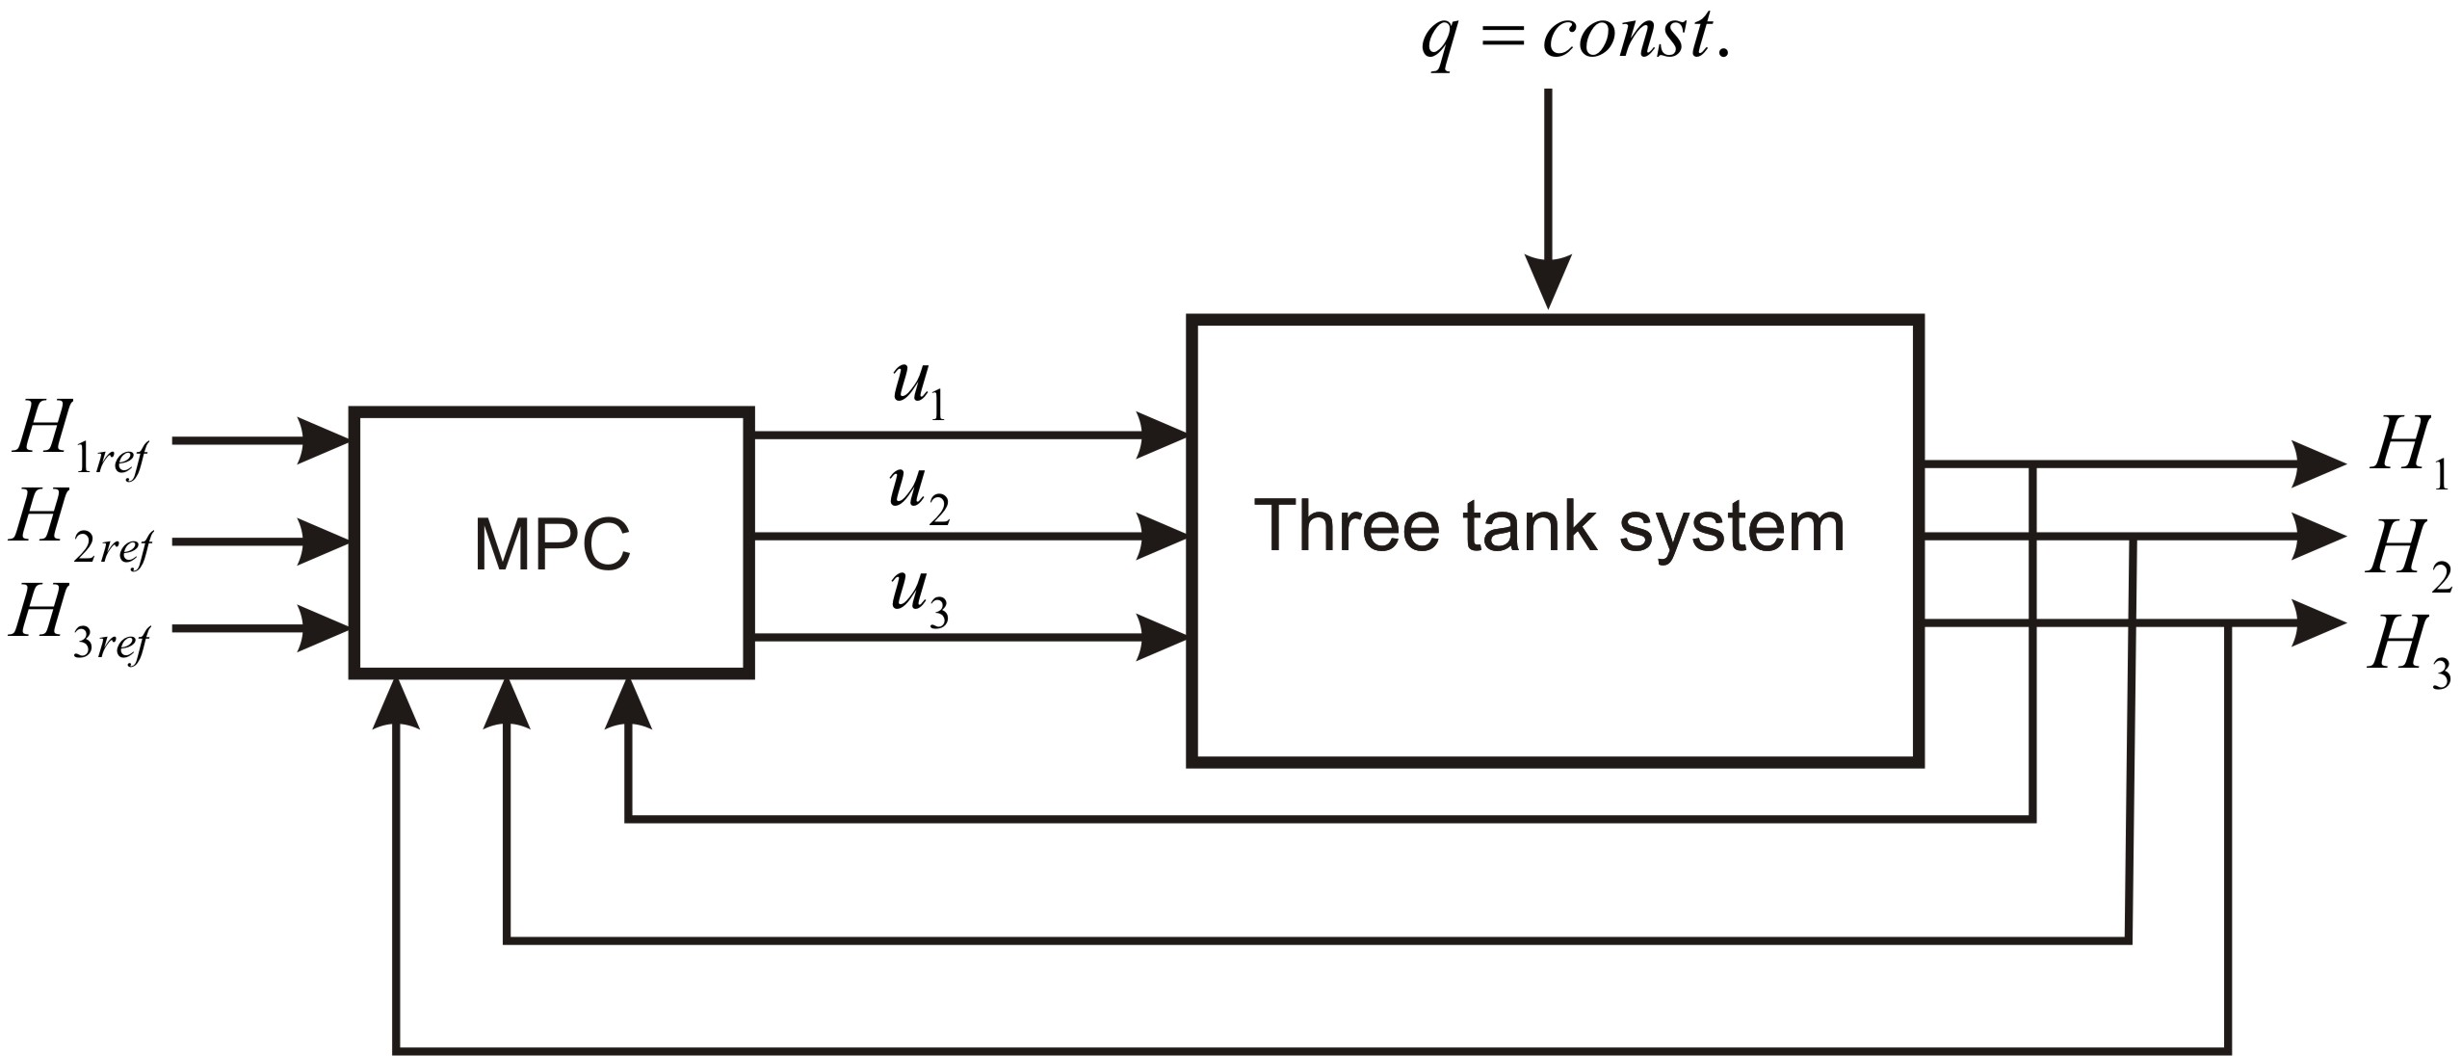
Fig. 2 Valve-controlled three tank system

The laminar outflow rate of an “ideal” fluid can be calculated according to Bernoulli law:
, (1)
whereis the orifice outflow coefficient,is the output area of the orifice,is the level of the liquid in the tank , and is the gravitational acceleration.
If the value for the openness of the valve is defined by , where is fully opened valve constant, is the coefficient which determines how much the valve is opened, the following equation is obtained:
, (2)
where .is the value which depends on turbulence and acceleration of the liquid, and it can be different for the different kind of fluids.
The system dynamics is described by:
(3)
From (3), it can be obtained:
(4)
where is a cross sectional area of thetank at the level, and the other parameters of the tanks are (Fig. 3): , , , , , .

Substituting (4) in (3) yields:
(5)

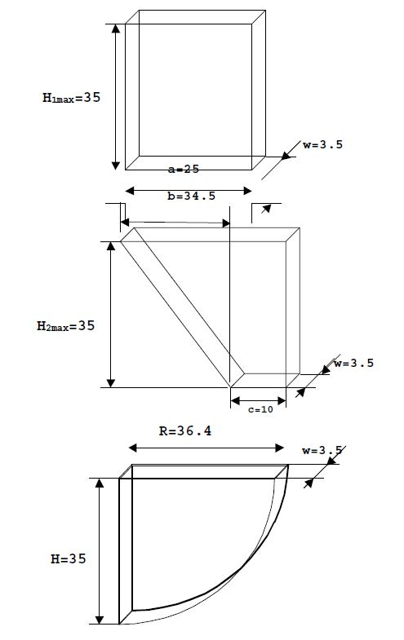
Fig. 3 Dimensions of the tanks

The last set of equations is a nonlinear model of the observed system and completely describes its dynamics. In order to implement the proposed control algorithm, a linearized model of this system is required.

3. Linearized model of the three tank system
The equilibrium point of the system is obtained by equating the right side of the (5) with zero:

(6)
Using (6), the equilibrium point is calculated by:
. (7)
By denoting
,
the equation (5) can be reformulated as:
(8)
Using the Taylor expansion of (8), around the obtained equilibrium point, the linearized model is obtained by
, (9)
where is a deviation from the equilibrium point , is a deviation from the control . Jacobian matrices of the (8) are then determined by
, for .
For the three tank system described by (8), the obtained Jacobians have the following form:
,
where , , , , , , , , , , , , , , , , , , .
Now, the linearized model of the system can be represented in the form of a linear differential equation:
, (10)
where matrices and are already obtained Jacobians and , respectively.

4. Design of MPC of three tank system

In order to define the increment of the control signal, and to design MPC based on Laguerre functions, the augmented model of the system is obtained by introducing the integrators:
(11)
where matrices , , and are discrete-time matrices of the system.
The optimized control trajectory
(12)
consists of the increments of the control signal in the control horizon and it is calculated by
(13)

where
(14)

is Laguerre functions vector, and is Laguerre coefficient vector [8]. The parameters of the Laguerre functions are determined from the difference equation of the discrete-time Laguerre functions defined as:
(15)
where the matrix , containing the parameters of the Laguerre network, and , is given in the following form:
(16)
and the vector of the initial conditions is
. (17)
The optimal control action is then calculated by

(18)

where represents the number of inputs.

5. Digital simulation results
After the linearization method described in Section 3, the following Jacobian matrices of the three tank system are obtained:

(19)

The parameters that are used for the Jacobians and the simulations are:

- ,
- ,
- ,
- ,
- .
The simulations are conducted, and the robustness of the proposed controller is examined. As it was mentioned before, the equilibrium point is calculated for the equal value of the tanks levels of , and the referent tank level values are chosen as:
.
It can be seen that the referent levels are achieved using the proposed MPC, and the desired values of the fluid levels for the first, second and third tank are shown in Figs. 4, 5 and 6, respectively:

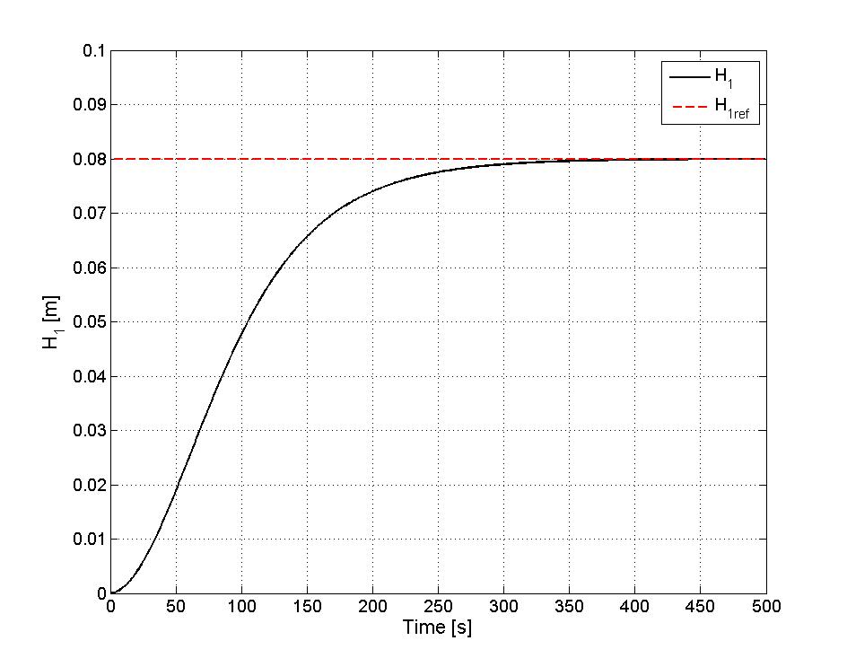
Fig. 4 Level H₁
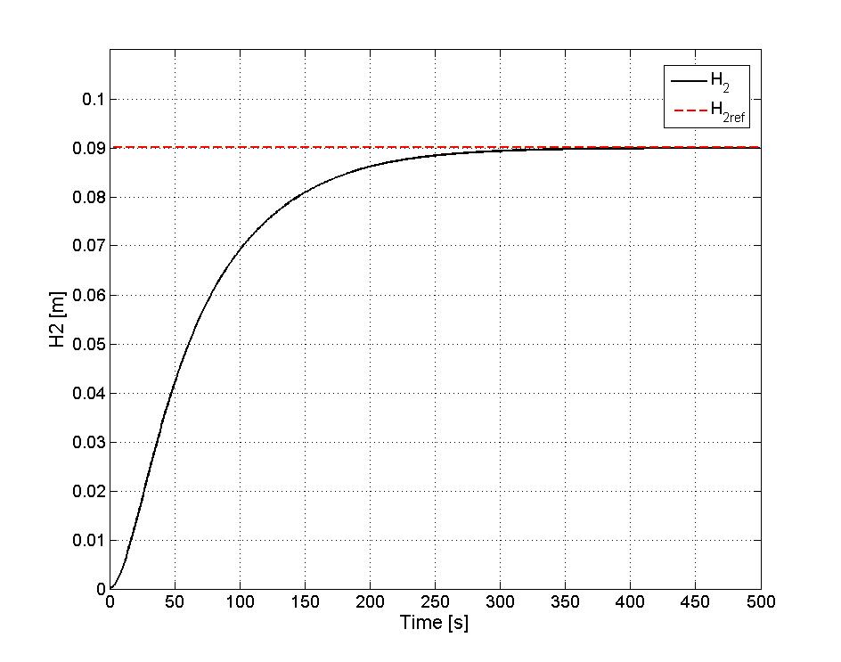
Fig. 5 Level H₂
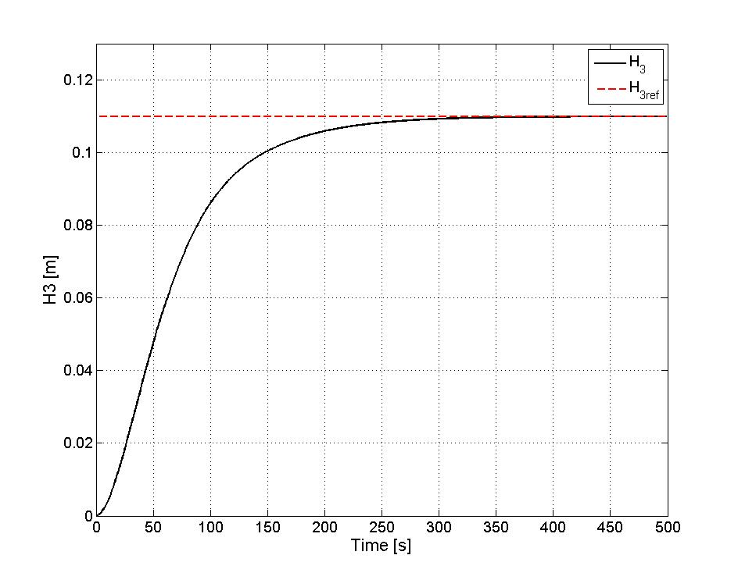
Fig. 6 Level H₃

The proposed discrete-time MPC based on the Laguerre functions, defined by (17), applied to the plant described by (10) results in the control signals depicted in Figs. 7, 8 and 9.
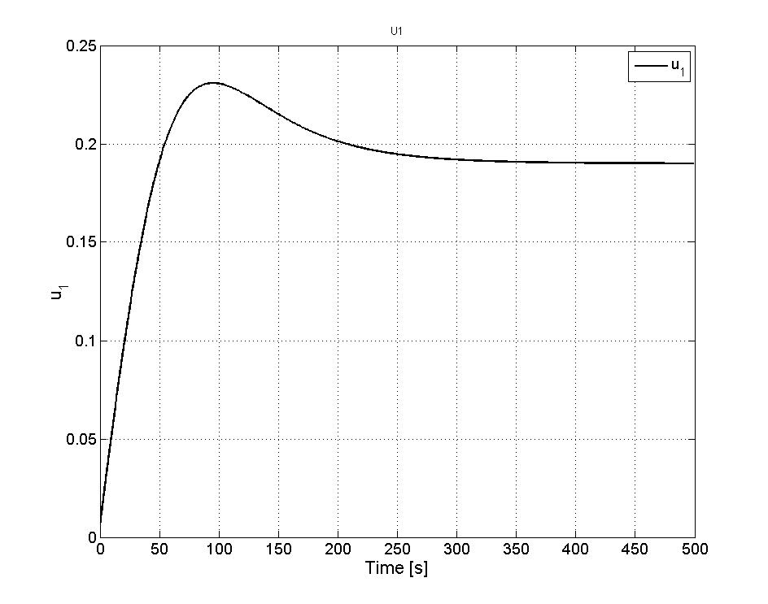
Fig. 4 Laguerre functions based MPC signal
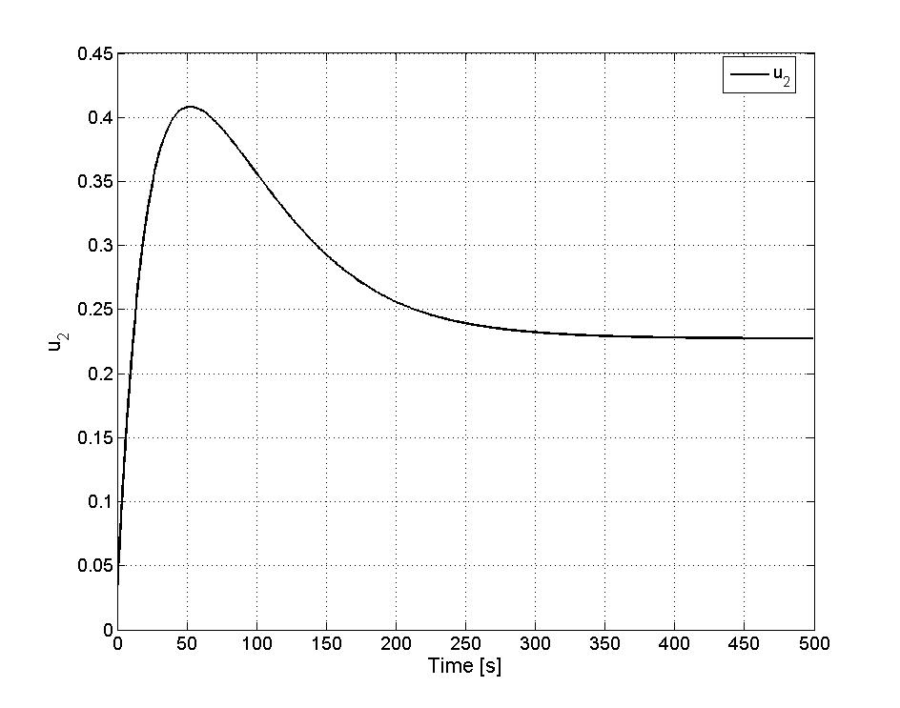
Fig. 5 Laguerre functions based MPC signal
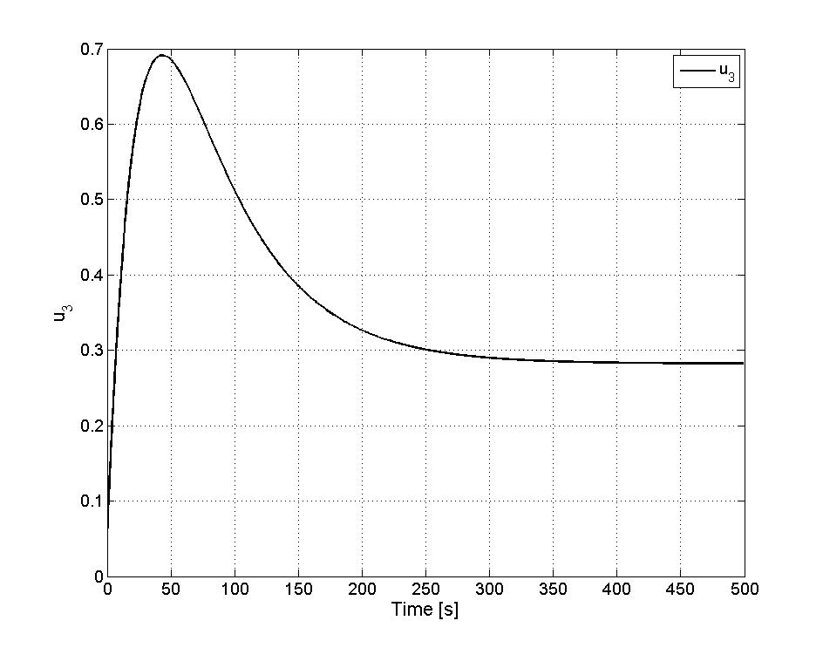
Fig. 6 Laguerre functions based MPC signal

6. Conclusion
This paper describes the application of digital model predictive control (MPC) based on the Laguerre functions applied to the nonlinear system with multiple inputs and outputs. As a control object, the system with three reservoirs of different shapes and dimensions was used. The system is valve-controlled. Digital MPC has been designed and implemented, and satisfactory results have been obtained regarding the robustness of the proposed controller.
For the future work, it is planned to use the other orthogonal, near-orthogonal and quasi-orthogonal functions of the Legendre type. In order to cope with the disturbance, a combination of MPC and sliding mode control should be considered. This combination could use the good features of each of the aforementioned control algorithms to obtain an optimal control law.

References
- Ј. B. Burl, “Linear Optimal Control – H₂ and H∞,” Addison-Wesley Longman, Inc., USA, 1999.
- F. L. Lewis, V. L. Syrmos, “Optimal Control,” John Wiley&Sons. Inc., New York, 1995.
- M. Hovd, R Michaelsen, T Monti, “Model predictive control of a crude oil distillation column,” Computers & chemical engineering,, vol. 21, Supplement, pp. S893-S897, 1997.
- S. J. Qin, TA Badgwell, “A Survey of Industrial Model Predictive Control Technology,” –Control Engineering Practice, vol. 11, no. 7, Elsevier, pp. 733–764, 2003
- M. Hovd, “A Note on the Smoothing Formulation of Moving Horizon Estimation,” Facta Universitatis Series: Automatic Control and Robotics, vol. 11, no. 2, pp. 91-97, 2012.
- K. S. Holkar, L. M. Waghmare, “An Overview of Model Predictive Control,” International Journal of Control and Automation, vol. 3, no. 4, pp. 47-64, 2010.
- L. Wang, “Model Predictive Control System Design and Implementation Using MATLAB,” Springer, 2009.
- Inteco, "The laboratory anti-lock braking system controlled from PC," User’s manual, 2008. [Online]. Available: www.inteco.com

  Received February 24, 2013 Corresponding author: Miodrag Spasić Faculty of Electronic Engineering, Aleksandra Medvedeva 14, 18000 Niš, Republic of Serbia E-mail: miodrag.spasic@elfak.ni.ac.rs
 Acknowledgement: This paper was realized as a part of the projects III 43007, TR 35005, financed by the Ministry of Education and Science of the Republic of Serbia within the framework of integrated and interdisciplinary research for the period 2011-2018.

