Hybrid GPS/SINS System - An Overview*
UDC
Milan Andrejević¹, Aleksandra Milovanović², Saša S. Nikolić²
¹Air Force and Air Defense Training Center, Training Command, Serbian Army General Staff, Pukovnik Milenko Pavlović bb, 11080 Belgrade, Republic of Serbia
²University of Niš, Faculty of Electronic Engineering, Department of Control Systems, Aleksandra Medvedeva 14, 18000 Niš, Republic of Serbia
Abstract. This paper describes a hybrid navigation system consisting of an integrated GPS/INS system. The integration of navigation systems has been performed to improve the accuracy of the navigation parameters and it is a current trend in the world. The need for continuous navigation, during the change of position of the GPS receiver, during the closing time of the GPS receiving antenna, and during the appearance of interference, has imposed a solution that is achieved by the integration of GPS / INS. The role of the SINS, which is part of the integrated GPS / INS navigation system, is to determine the navigation parameters at intervals between two adjacent measurements of GPS receivers, i.e., at times when there is no GPS navigation information for any reason. In this way, GPS and INS, when used together, complement and correct each other, significantly increasing the reliability and accuracy of the hybrid navigation system.
Key words: navigation systems, global positioning system, strapdown inertial navigation system, Kalman filter

1. Introduction
The process of tracking a route on a map using predetermined and given geographic coordinates of the route points is called navigation, and the process of managing an aircraft to monitor a given route is called guidance. The basic tasks of navigation are: Determining the current position of the aircraft in the reference coordinate system; Determination of the relative position of the aircraft relative to the point at which it is, at the intended task, to be at that moment; Maneuvering in order to reach a planned point (navigation in the broad sense); Determination of other navigation parameters for display and application in other avionics systems.
All aeronautical navigation systems can be subdivided according to technical realization into [1]:
- Radio navigation systems (VOR, DME, LORAN, OMEGA, etc.)
- SNS satellite navigation systems (GPS, GALILEO, BEIDOU, GLONASS, etc.)
- Doppler Navigation Systems (DNS)
- Inertial Navigation Systems (INS)
- Hybrid or integrated navigation systems, which can be a combination of the above systems that are closed looped with or without optimal filtration (Kalman filter), thereby significantly increasing the accuracy and reliability of the hybrid system.
VOR (Very High Frequency Omnidirectional Range) system is used to measure the azimuth of an aircraft relative to a terrestrial transmitter (radio beacon). It consists of a ground-based VOR transmitter and an aeronautical VOR receiver. The performance of the VOR system is limited by two main factors: the local error due to reflection from objects near the ground transmitter and the error of measuring the phase difference of the 30 Hz signal in the aircraft VOR receiver.
DME (Distance Measuring Equipment) is an impulse system for measuring the distance from an airplane (DME transceiver) to a ground DME station (transceiver). Each DME station can serve 50 to 100 aircraft at a time. Terrestrial DME stations are usually located at the location of VOR stations, and together they make the system of closer navigation. This increases the reliability and availability of the entire VOR / DME system.
LORAN (LOORAN - LOng RAnge Navigation) is an impulse hyperbolic system of further navigation [1]. This system is based on measuring the difference of distances to earth stations. In this way, position lines (lines of constant parameters of object position) are determined, in which section the position of the aircraft is determined. For accurate measurement, the transmitting antenna signals must be synchronized in time or phase.
OMEGA is a continuous hyperbolic system of further navigation of very long range. It works in the range of 10 to 14 kHz. The complete system consists of 8 Earth stations [1]. OMEGA receivers can operate at three frequencies (10.2 kHz, 13.6 kHz and 11.33 kHz) and can be single channel, dual channel and three channel. By measuring the phase difference of the corresponding signals from two stations, one hyperbolic position line is determined. The intersection of the position lines determines the position of the aircraft.
GPS (Global Positioning System) is one of the satellite navigation systems. GPS provides two services. A service that provides standard positioning accuracy (SPS - Standard Positionig Service) and a service that provides high precision positioning service (PPS - Precise Positioning Service).
GALILEO is a European satellite navigation system. It consists of 27 active and 3 backup satellites, which are located in 3 orbital planes at an altitude of 23,222 km above the Earth's surface [2]. GALILEO provides 5 services:
- Open service (1164 1214 MHz, accuracy 5-10 m)
- Safety of life service (accuracy 5 10 m)
- Commercial service (1260 1300 MHz, accuracy less than 1 m)
- Public regulated service (4-6 m accuracy)
- Search and rescue service.
The Inertial Navigation System (INS) is an autonomous system for determining navigation parameters [3]. Inertial sensors can be mounted on a servo-driven gyro-stabilized platform, or firmly attached to the body of the object. In the first case it is an INS with a gyro-stabilized platform and in the second case it is a strapdown inertial navigation system (SINS).

2. Reference coordinate systems and transformations
To solve the problem of satellite navigation, it is necessary to select a reference coordinate system in which it is possible to represent both the satellite and the user. Navigation requires at least two coordinate systems [4-7]. One, to show the position of the object and the other to display the navigation chart. Since accelerometer and gyroscope outputs provide acceleration and angular rotation data in a coordinate system of object (Body frame), a transformation matrix is used to transform coordinates from a body coordinate system into geographical coordinates, to obtain information about the trajectory of an object relative to Earth.
Coordinate system of object (Body frame) is a bound coordinate system, and it is determined by the type of object. In the case where the observed object is an airplane, its coordinate system is defined as follows: the x-axis direction coincides with the longitudinal axis of the fuselage, while the y-axis is directed along the right-wing axis at right angles to the x-axis. The z-axis direction is normal to xy plane and its direction is in the direction of the floor of the plane. All components in this system will have an index b.
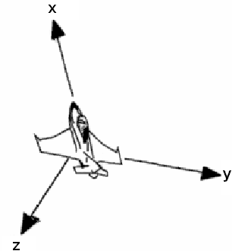
Fig. 1 Airplane coordinate system (Body frame)

The local coordinate system (NED frame) is linked to a local point on the Earth's sphere that is represented by its latitude and longitude used in navigation. The x-axis direction is a tangent to a given point and is directed north (N - North). The y-axis direction is also a tangent to the local point and is oriented east (E - East). The third, the z-axis, is normal to the xy-plane and is directed toward the center of the Earth, or down (D - Down). All components in this system will have an index of n.
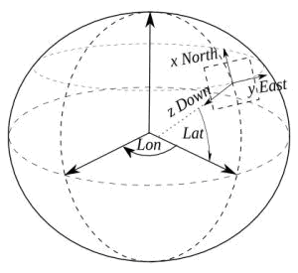
Fig. 2 The local coordinate system (NED frame)
The Swiss mathematician Leonhard Euler showed that it is necessary to perform a maximum of three consecutive rotations about the coordinate axes for certain angles in order to transform (rotate) the vector from one coordinate system to another. This is done by a simple DCM (Direction Cosine Matrix) trigonometric transformation around the individual axes. These angles are called Euler angles. They are defined in airplane navigation system as: roll angle -$φ$, pitch angle - , and yaw angle - .

Roll angle $φ$
This angle represents the rotation about the longitudinal axis of the airplane, which is actually the rotation about the x-axis in the airplane (body) frame. The positive rolling angle is clockwise. Airplane wings are in horizontal position when . The picture shows a 3D view of the roll angle:
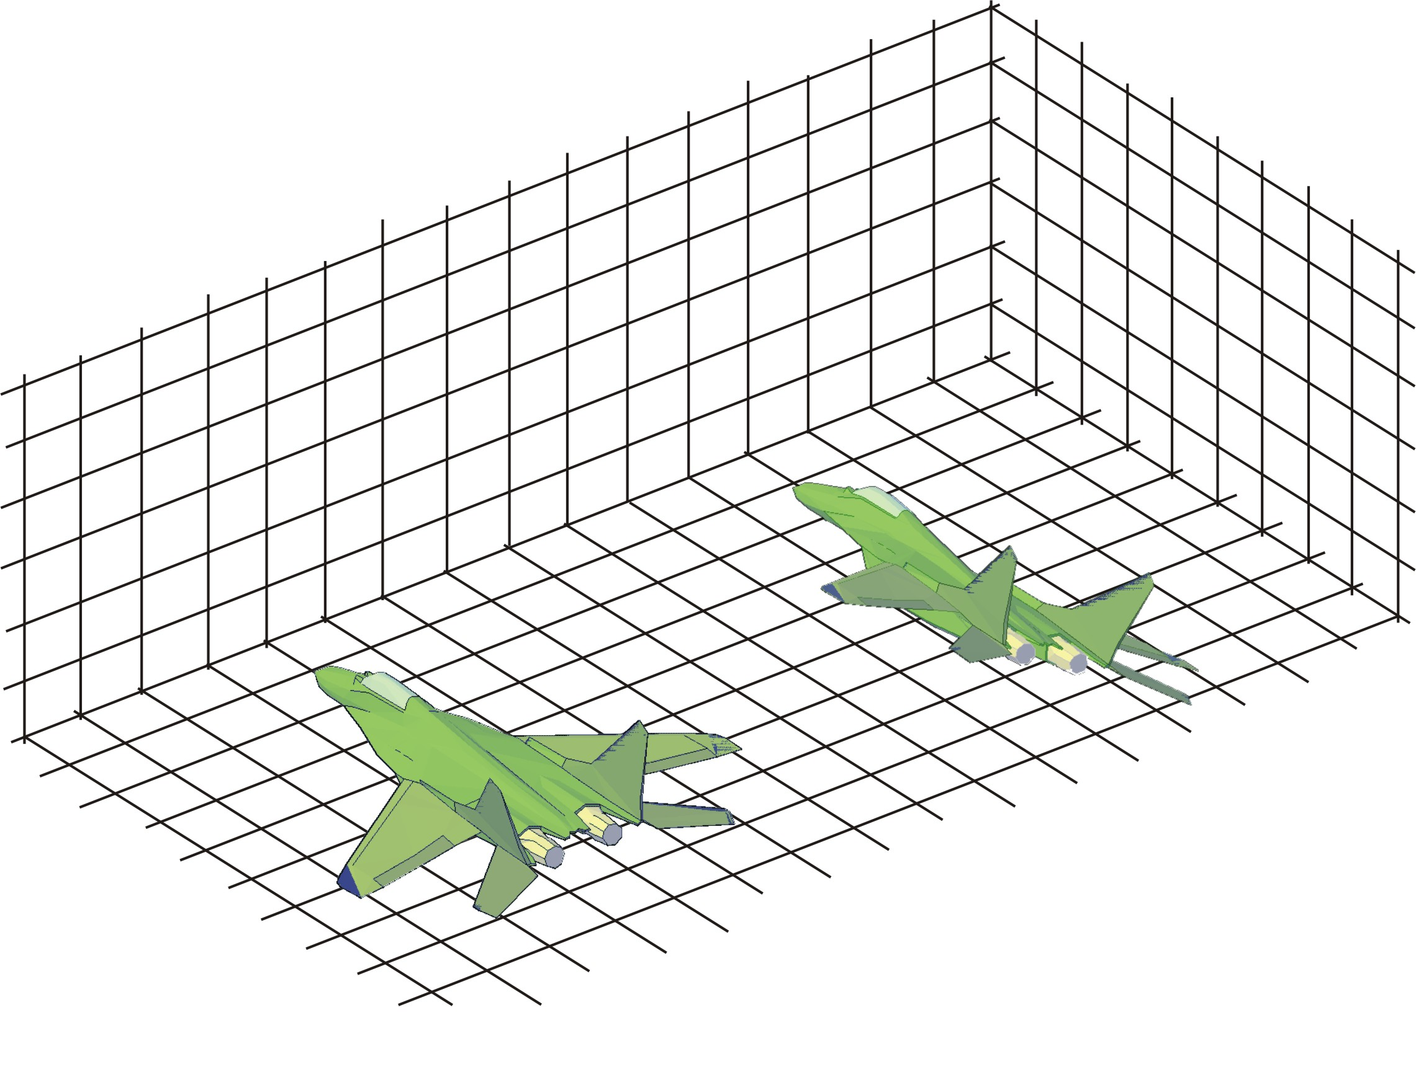
Fig. 3 Roll angle

Pitch angle $θ$
This angle represents the rotation about the y-axis in the airplane (body) frame. When the airplane is in a horizontal position, the pitch angle is . The next figure shows a 3D view of the pitch angle.
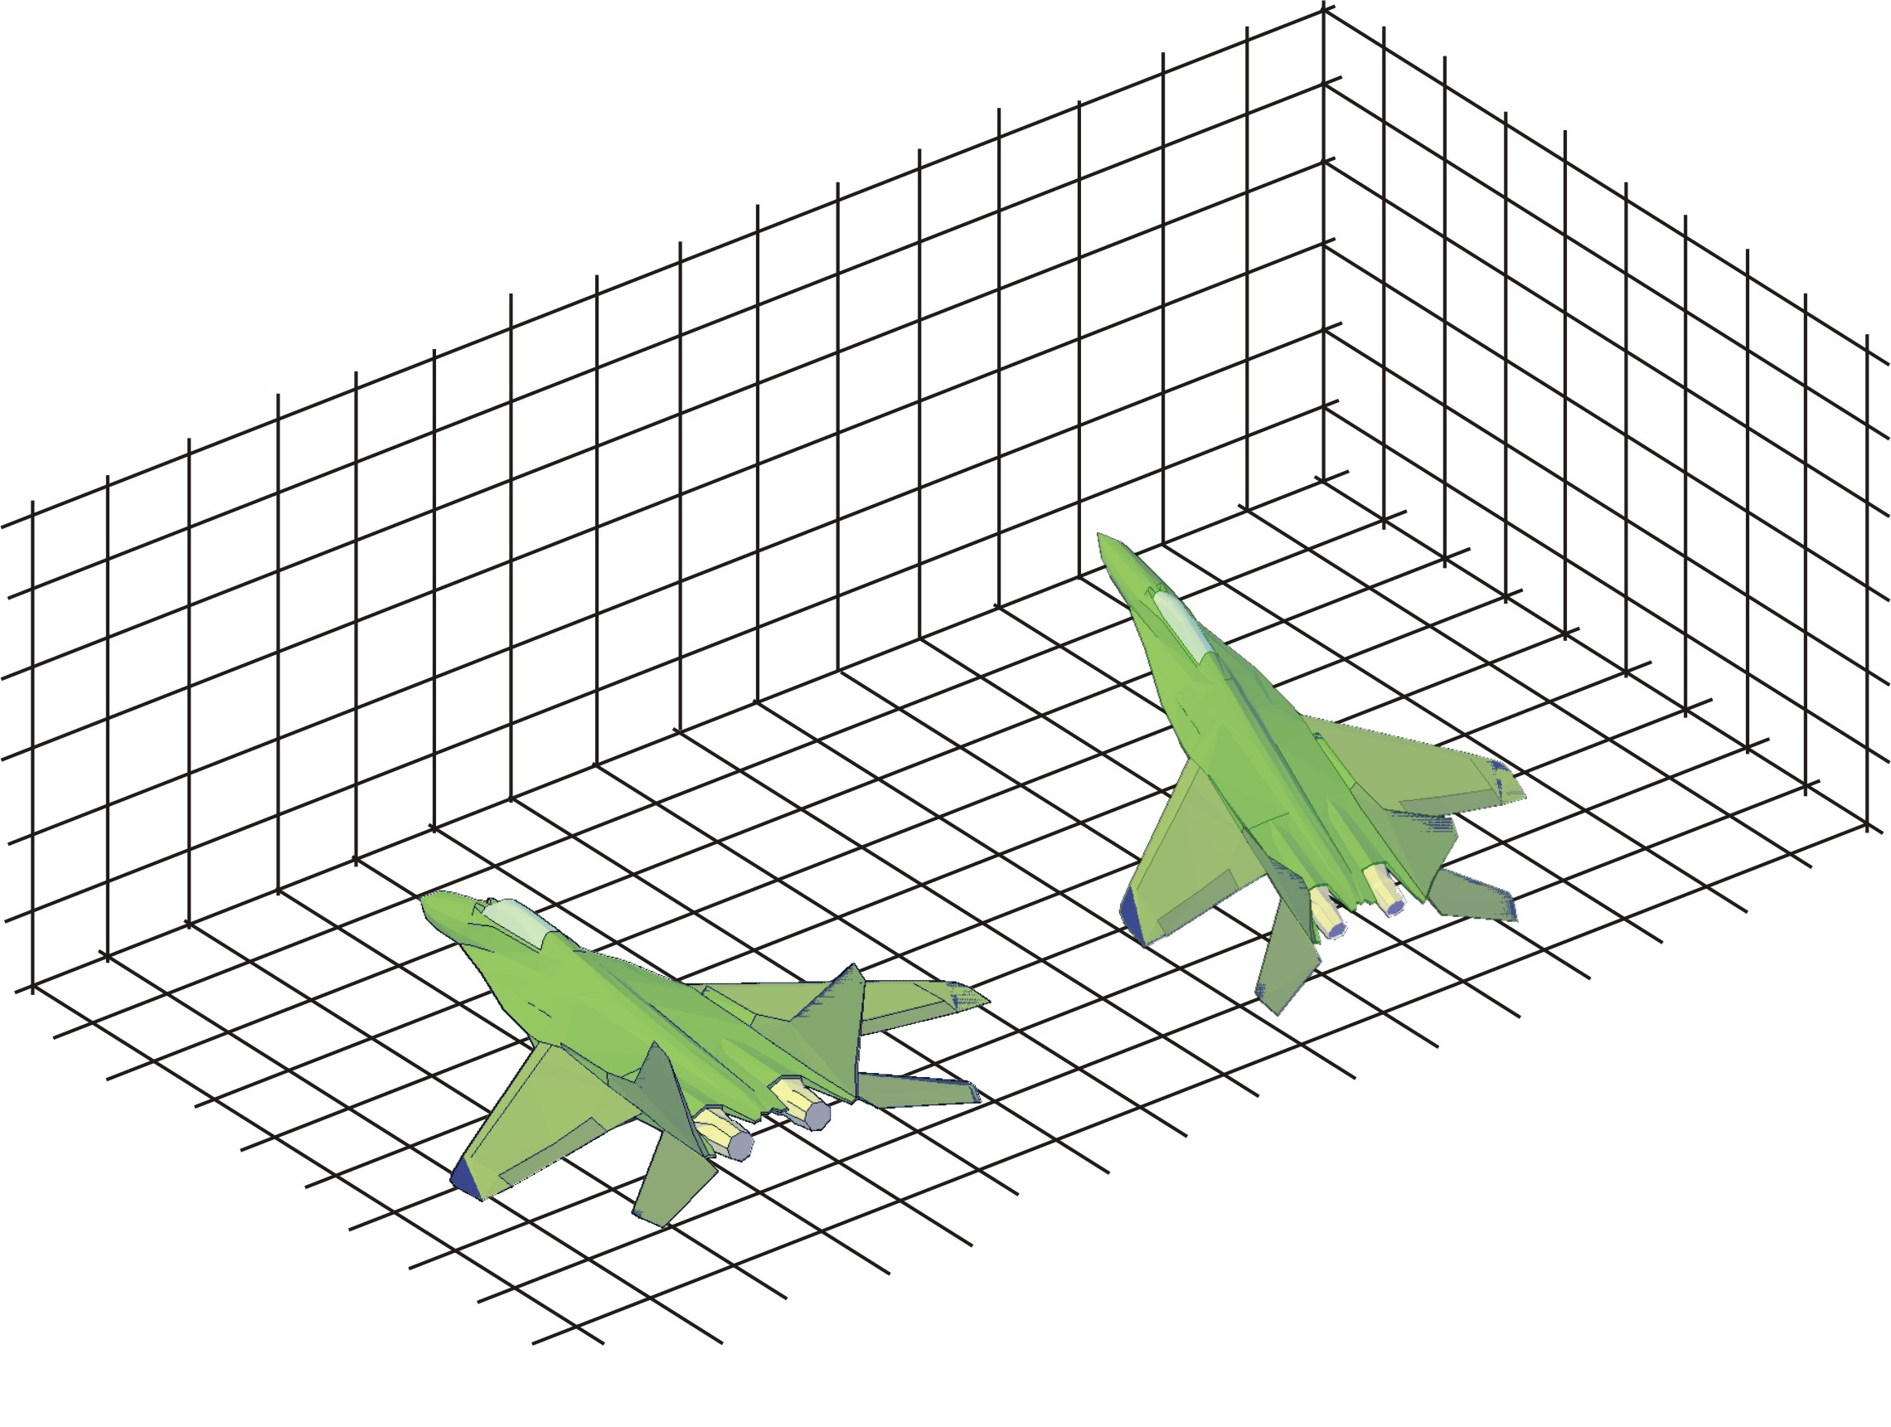
Fig. 4 Pitch angle

Yaw angle

The yaw angle represents the rotation about the z-axis in the airplane (body) frame. The positive rotation is clockwise around the z-axis. The figure gives a 3D view of the yaw angle.

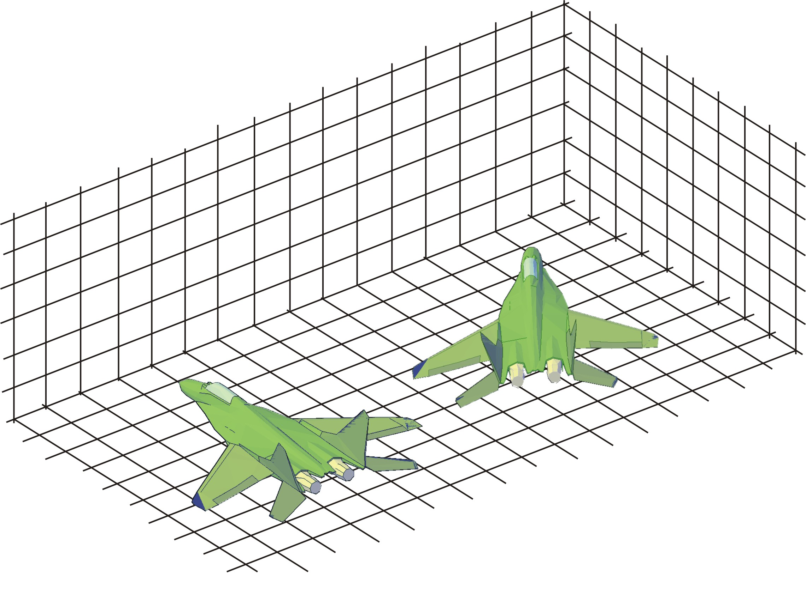

Fig. 5 Yaw angle

The elements of the transformation matrix can be calculated if we know the Euler angles using Eq . We can transform angular velocities from a body to a navigational (NED) frame, and obtain derivations of Euler's angles . Thereby, we must take into account the order of multiplication of Euler's angles. The relationship between the angular rotational speeds of the body frame and the derivation of the Euler angles is given by the equation:
(1)
The relations between the angular rotation speeds of the axis of the local NED frame and the derivation of the Euler angles are given in the form:
(2)

3. Strapdown inertial navigation systems
With the rapid development of processors and digital components, there is the emergence and rapid development of AHRS (Attitude Heading Reference System) [8]. In platformless inertial systems (SINS), accelerometers and gyroscopes are firmly attached to the body of the object. Thereby, the number of sensors should be sufficient to obtain information about the vector of apparent acceleration (specific force) of the object on which the sensors are mounted, and the vector that characterizes the rotation of the object. This information, together with the gravity field data and the initial motion conditions, is sufficient to calculate the navigation parameters characterizing speed, location and position. The basic equations of motion of an object in a body frame on the basis of which the speed and position of an object are calculated can be written in the form:
(3)
(4)
where are: V_{B} - vector of absolute velocity, R_{B} - vector of position of the center of mass of the object (geocentric radius), f - vector of specific force, g - acceleration caused by the gravitational field of the Earth and it is a function of the position of the object, and - angular velocity of the object in body frame. In the task of determining the orientation parameters, the calculation of the orientation angles (Euler angles), whose knowledge is necessary to control the angular motion of the object, and the calculation of the "cosine of directions" between the axes of the body and inertial frame, can be singled out. The following operations performed on an INS "strapdown" computer refer to the determination of the geographical coordinates of the object's position and roll angle-$φ$, pitch angle-, and yaw angle-. The basic information for determining the navigation parameters R (position) and V (velocity) in the selected coordinate system and determining the orientation of the object with respect to it, is the information obtained from accelerometers and gyroscopes that are firmly attached to the body of the object.
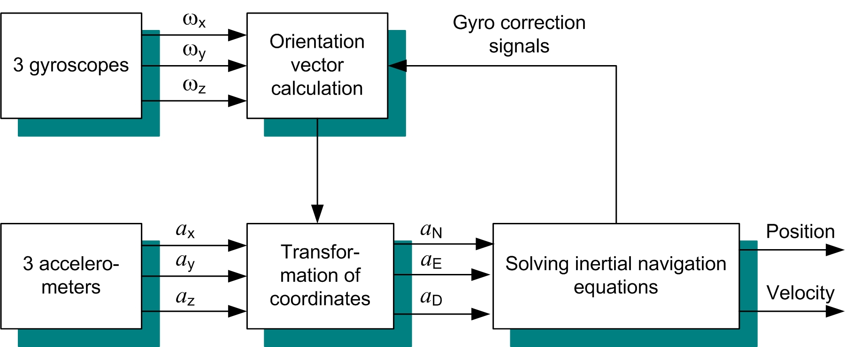
Fig. 6 Block diagram of the "strapdown" inertial navigation system
In addition to the acceleration information, obtained from accelerometers positioned in the axis of the body frame, and information on the angular velocity of rotation of the axes of the body frame, information is also needed on the Earth model used in the navigation system, on the basis of which determines the relative velocity and position of the object. The information about the initial values for V and R is also entered into the "strapdown" INS computer. To determine the projection of specific forces on the axis of the reference navigation system N, it is necessary to determine the transformation matrix , which is used to transform the coordinates from the body frame B to the reference coordinate system N. The transformation matrix , is obtained by solving the orientation algorithm. Gyroscale rebalancing signals, which are referred to in Figure 6 as "gyroscope correction signals," are also formed in the computer SINS thereby reducing the angle-of-magnitude limitations that gyroscopes can measure.
Modern linear estimation techniques require an adequate dynamic model of the system whose states are estimated. In addition to knowing the dynamics of the system, it is necessary to define an appropriate model of the system noise, so that the differential equations by which the given model of the system is described are complete. The system noise model can be described by knowing the sources of errors that exist in the inertial navigation system and by knowing their statistics. Most error sources are random variables, and therefore INS errors can be described as stochastic processes. Stochastic processes are random processes whose variables are a function of time. Most of these processes can be described by differential equations, which use the white noise function. White noise is the mathematical idealization of a signal that contains infinite energy and whose width of the frequency spectrum is infinite.
- Errors in inertial navigation systems, depending on the source of the error, can be divided into:
- Errors caused by imperfections of inertial sensors.
- Errors as a result of initial ineligibility.
- Errors as a result of errors in the calculation process in the navigation computer.
- Errors due to environmental impact (influence of wind, temperature, vibration of the body of the object, phase of flight of the object, etc.).
4. Global Positioning System
The Global Positioning System (GPS) is an optimal positioning system that provides accurate, continuous and widely available information on three-dimensional position and speed to its users [9]. User is any person or agent who owns a GPS receiver. GPS also provides time synchronization for all users in GPS system time. GPS can be divided into three segments: spatial, control, and user. The space segment consists of 24 satellites, located in six orbital planes with four satellites in each plane. The satellites are so deployed that they provide at least four satellites in the field of view of the user at any time, anywhere. The control segment consists of the main control station and five monitoring stations. The basic function of the main control station is to track, monitor and control the position of GPS satellites. The user segment consists of a GPS antenna and a receiver, specifically designed to receive, decode and process code for distance measurement and navigation messages, which are contained in a satellite GPS signal. If the clock on the satellite and the clock in the GPS receiver are synchronized in time, the positioning of the user can be obtained based on measuring the distance from the user to three different satellites.
GPS uses the concept of measuring the propagation time of a signal, from one point to another point in space, to determine the position of the user. This concept involves measuring the time difference from the moment a signal is transmitted from a satellite, whose position is known, to the time the signal reaches the GPS receiver. The resulting time interval represents the time of spread of the GPS signal. Multiplying the measured time interval by its velocity gives the magnitude of the distance from the satellite to the GPS receiver. Based on the measured distances of several satellites whose locations are known, the receiver determines its position. If the user is measuring only with respect to one satellite, then the set of possible solutions of the user's position is on the circle of radius R1. If the user measures the distance of two satellites in the same way, then the possible positions of the user will be obtained at the intersection of two circles, whose radii are R1 and R2. The radius R1 represents the distance from the first satellite, and the radius R2 represents the distance from the second satellite. In this case, the solution to the user's position is not clearly defined. Solving the problem of non-equilibrium can be achieved by introducing distance measurements from the third satellite, as shown in Figure 7. From the figure, it can be observed that the intersection of all three circles is realized only at point A, which represents a uniquely determined position of the user.
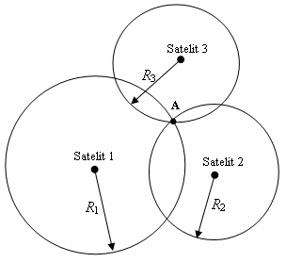
Fig. 7 Determining the position of the user by measuring the distance of three satellites
In the previous consideration, it was assumed that the GPS receiver clock and the satellite clock were time synchronized. However, this is practically not the case. In this case, the time interval of signal propagation, from satellite to user, will be incorrectly measured. Based on the error present in measuring signal propagation time intervals, there is an error in measuring the distance from the satellite to the user. The user position determination error can be eliminated by introducing a GPS receiver clock offset size compensation.
In general, GPS accuracy depends on the quality of the distance measurements and the data obtained from the satellite "ephemeris" (satellite position). System errors are errors that occur in the control segment, satellite, and user segment. To analyze the effect of errors on the accuracy of GPS measurements, it can be assumed that all errors attributed to individual satellites represent an equivalent error expressed in magnitude of the pseudorandom distance. GPS accuracy, as a magnitude that depends on the accuracy of the pseudorandom distance, is expressed on the basis of the UERE - User Equivalent Range Error. The UERE for a given satellite represents the (statistical) sum of individual errors that contribute to the total error. Typically, the individual components of the total error are considered independently, and the total UERE for a given satellite is represented as a Gaussian random variable with zero mean and variance equal to the sum of the variance of each individual component of the UERE error. UERE is usually assumed to be an independent and identically distributed error from satellite to satellite.
5. GPS / SINS integration methods
Kalman’s filtration is an optimal estimation technique that performs an optimal estimation of values given by a system. As a linear filter, a recursive algorithm is used to process the measurement information in a discrete time. It is a statistical technique that combines knowledge of the statistical nature of system errors with knowledge of system dynamics, which is represented by a model in the state space. Based on the knowledge of the dynamic system state model and the system noise model, the state of the system is evaluated. System states can include a number of variables. In navigation systems, it usually works with a minimum of two system states (position and speed). The estimated condition is derived from Kalman amplification, which is optimized to obtain minimal error variance. For this reason, the Kalman filter (KF) is the optimal filter. KF is designed to calculate corrections in a system based on external measurements. The magnitude of the correction corresponds to the current filter estimate. Kalman filtration involves two major steps: prediction and correction. The correction represents the estimation of the state vector at a given moment based on information about all previous measurements. Prediction is the process of estimating the state vector in the next moment, based on the dynamic model of the system.
Integration methods can be classified into two categories. The first category is based on the coupling type of the system and depends on the architecture of the system itself. This group of methods includes: loosley coupling and tight coupling hybrid GPS / SINS configuration. The loosley coupled configuration includes a GPS receiver with KF, an IMU, and a navigation processor with KF. This configuration is shown in Figure 8.
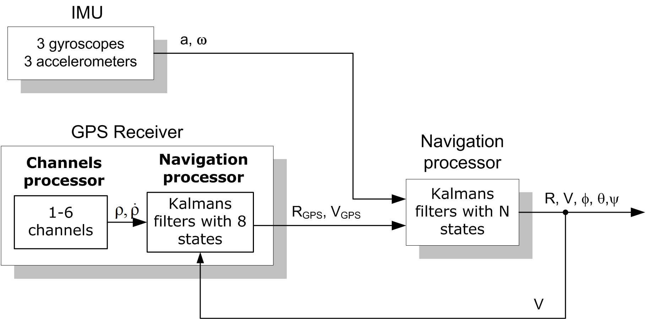
Fig. 8 Loosley coupled hybrid GPS / SINS configuration
Although used in many initial applications, this system has a forward loop in the navigation processor and two separate filters that create the possibility of instability caused by reciprocal feedbacks. The simulation for this configuration must be fully defined to ensure the continuity of operation of both filters. In situations where there is instability, the amplification of the filter decreases, which can result in slow system operation.
Another type of configuration is shown in Figure 9. In a tightly coupled system, KF sends data from the GPS navigation processor directly to the channel processor.
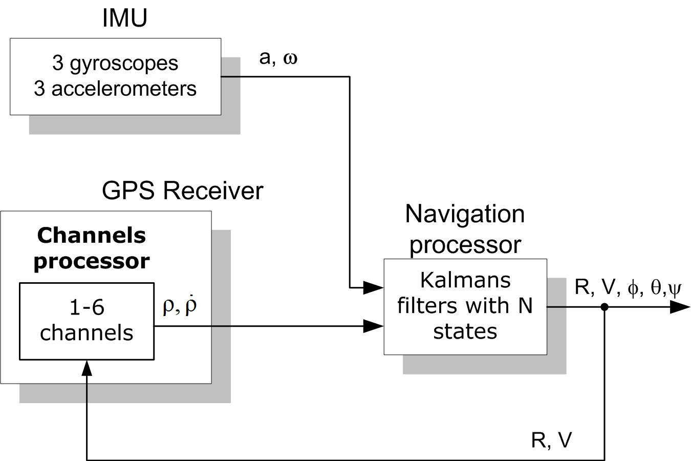
Fig. 9 Tightly coupled hybrid GPS / SINS configuration

In this configuration, the non-model errors that exist at the output of the Kalman GPS receiver filter are eliminated.
The second category of integration is based on the method of combining or processing GPS and SINS information to obtain navigation data. This group of methods includes: centralized (closed) and cascaded (open) GPS/SINS integration scheme. The centralized scheme involves the formation of a common navigation algorithm for an inertial and satellite navigation system with a general error model used in determining the navigation parameters. Since there are no universal algorithms for different accuracy classes of SINS, it is therefore necessary to modify the algorithm on a case-by-case basis.
In the cascade scheme of GPS/SINS integration only the correction of the navigation information at the output of the inertial navigation system is provided, based on the measured sizes of the navigation parameters by the GPS receiver, without changing the navigation algorithms for processing the information obtained from the inertial and GPS systems. Notwithstanding some of the advantages of this method in terms of practical implementation, this scheme is not suitable for use in conditions of application of low-accuracy inertial sensors, which exhibit feature instability and where accuracy may differ even for sensors within a single series.
The Global Positioning System (GPS) provides accurate, continuous and widely available information on three-dimensional position and speed of the user. GPS also provides time synchronization for all users in GPS system time.
INS is an autonomous navigation system that is resistant to the effects of electronic interference and is therefore suitable for use in conditions of intense electronic interference. The inertial navigation system generally includes the IMU and all other equipment used to stabilize and process the output of the inertial sensors in order to obtain a three-dimensional position and speed in the selected coordinate system.
5. CONCLUSION
The most commonly used method for integrating GPS/SINS is KF. Kalman filtration is an optimal estimation technique that performs an optimal estimation of the values described by a system. It is a statistical technique that combines knowledge of the statistical nature of system errors with knowledge of system dynamics, which is represented by a model in the state space. Based on the knowledge of the dynamic system state model and the system noise model, the state of the system is evaluated. The estimated condition is derived from Kalman amplification, which is optimized to obtain minimal error variance.
Based on the analysis of the operation of some GPS/SINS systems, it was concluded that its accuracy depends on the frequency of GPS navigation information received. It has been shown that by integrating two fundamentally different navigation systems, a high-accuracy navigation system can be obtained that takes advantage of individual systems to correct their shortcomings. In the future, the integration of navigation sensors with other sensors in the aircraft will be of great importance. In military systems, information received from many sensors will be stored in a central database to ensure their optimal use.

References
- S. Janićijević, Elektronska oprema vazduhoplova, VTVA, Belgrade, Serbia, 1987.
- S. Janićijević, Vazduhoplovni instrumenti visinska i letačka oprema, Vojnoizdavački zavod, Belgrade, Serbia, 2006.
- A.D. King, "Inertial navigation – forty years of evolution", GES Reviw, vol. 13, no. 3, pp, 140–149, 1998.
- R. Stančić, Integracija sistema inercijalne navigacije i globalne orjentacije sa ciljem povećanja tačnosti i smanjenja osetljivosti na smetnje, M.Sc. thesis, Elektrotehnički fakultet, Beograd, 2002.
- C. Hide, T. Moore, M. Smith, "Adaptive Kalman filtering for low-cost INS/GPS", The Journal of Navigation, vol. 56, no. 1, pp. 143–152, 2003. [Online]. Available: https://doi.org/10.1017/S0373463302002151
- S. Kocaman, "GPS and INS integration with Kalman filtering for direct georeferencing of airborne imagery", Geodetic Seminar Report, Zurich, Switzerland, 2003.
- M. Kayton, W. Fried, Avionics Navigation Systems. John Wiley  Sons Inc., 1997.
- J.H. Kwon, "Airborne vector gravimetry using GPS/INS", Ohio State University, Geodetic Science and Surveying, Techical Report. no. 453, 2000. [Online]. Available: http://hdl.handle.net/1811/78664
- M. Grewal, L. Weill, A. Andrews, Global Positioning Systems Inertial Navigation and Integration. John Wiley Sons, 2001.

*Received May 17, 2020 Corresponding author: Saša S. Nikolić University of Niš, Faculty of Electronic Engineering, Department of Control Systems, Aleksandra Medvedeva 14, 18000 Niš, Republic of Serbia E-mail: sasa.s.nikolic@elfak.ni.ac.rs

