Editor-in-Chief
Danijel Danković
University of Niš, Faculty of Electronic Engineering
Republic of Serbia, 18000 Niš, Aleksandra Medvedeva 14
Phone: +381 18 529 325
Fax: +381 18 588 399
e-mail: danijel.dankovic@elfak.ni.ac.rs
Letter of Submission
I would like to submit the manuscript entitled Reviewing the photovoltaic potential of Bijeljina in the Republic of Srpska for consideration for possible publication in Scientific Journal Facta Universitatis, series Electronics and Energetics.
The authors of this manuscript have directly participated in the planning, execution, or analysis of this study. The authors of paper have read and approved the final version submitted.

We declare that the paper is original, has not been submitted for publication in other journals and has not already been published.

We, the undersigned authors, hereby transfer the ownership of copyright of the paper to Scientific Journal Facta Universitatis, series Electronics and Energetics.

Yours sincerely,
Ivana Radonjić Mitić
Address: University of Niš, Faculty of Sciences and Mathematics, Department of Physics, Višegradska 33, 18000 Niš, Republic of Serbia
Phone: +381644277728
Fax:
E-mail: ivana.radonjic-mitic@pmf.edu.rs

Authors/coauthors (name and signature)

Ivana Radonjić Mitić | 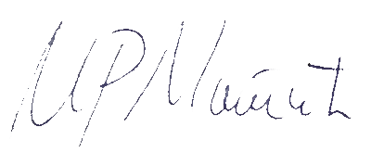
Tomislav Pavlović | 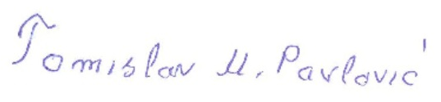
Dragoljub Mirjanić | 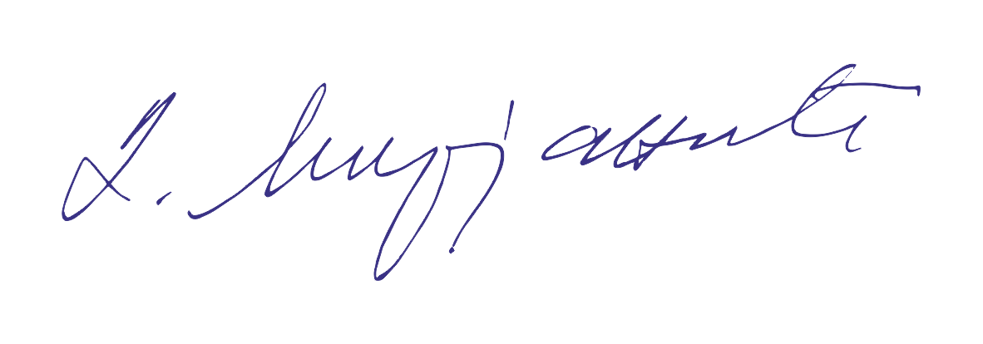
Darko Divnić | 
Lana Pantić Ranđelović | 

