Editor-in-Chief
Dragan Marinković
University of Niš, Faculty of Mechanical Engineering
Republic of Serbia, 18000 Niš, Aleksandra Medvedeva 14
e-mail: fumeed@junis.ni.ac.rs
Letter of Submission
&
CONflict of interest statement
I would like to submit the manuscript entitled
WEAR LOAD CAPACITY OF CROSSED HELICAL GEARS
for consideration for possible publication in scientific journal Facta Universitatis, series Mechanical Engineering.
The authors of this manuscript have directly participated in the planning, execution, or analysis of this study. The authors of the paper have read and approved the final version submitted. We declare that the paper is original, has not been submitted for publication in other journals and has not already been published.

Conflict of interest statement
The authors declare the following conflict of competing interests:
____________________________________________________________________________________________________________________________________________________________________________________________________________________________________________

The authors declare no competing interests.
(tick the suitable box and add text, if necessary)

We, the undersigned authors, hereby transfer the ownership of copyright of the paper to Scientific Journal Facta Universitatis, series Mechanical Engineering.

Yours sincerely,
Name of the corresponding author
assoc. prof. Aleksandar Miltenović
University of Niš, Faculty of Mechanical Engineering, A. Medvedeva 14, 18000 Niš, Serbia
Phone: +381641318614
E-mail: aleksandar.miltenovic@masfak.ni.ac.rs

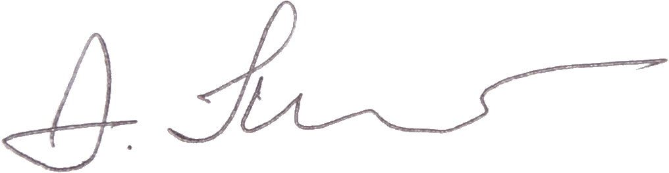
All authors/coauthors (name and signature):
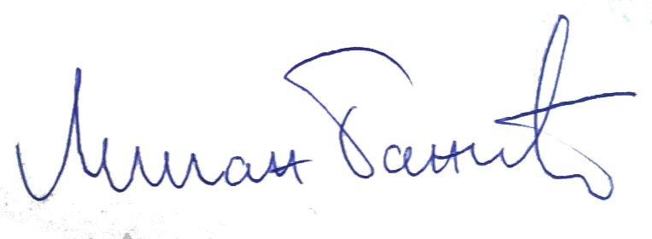
assoc. prof. Aleksandar Miltenović ________________________________
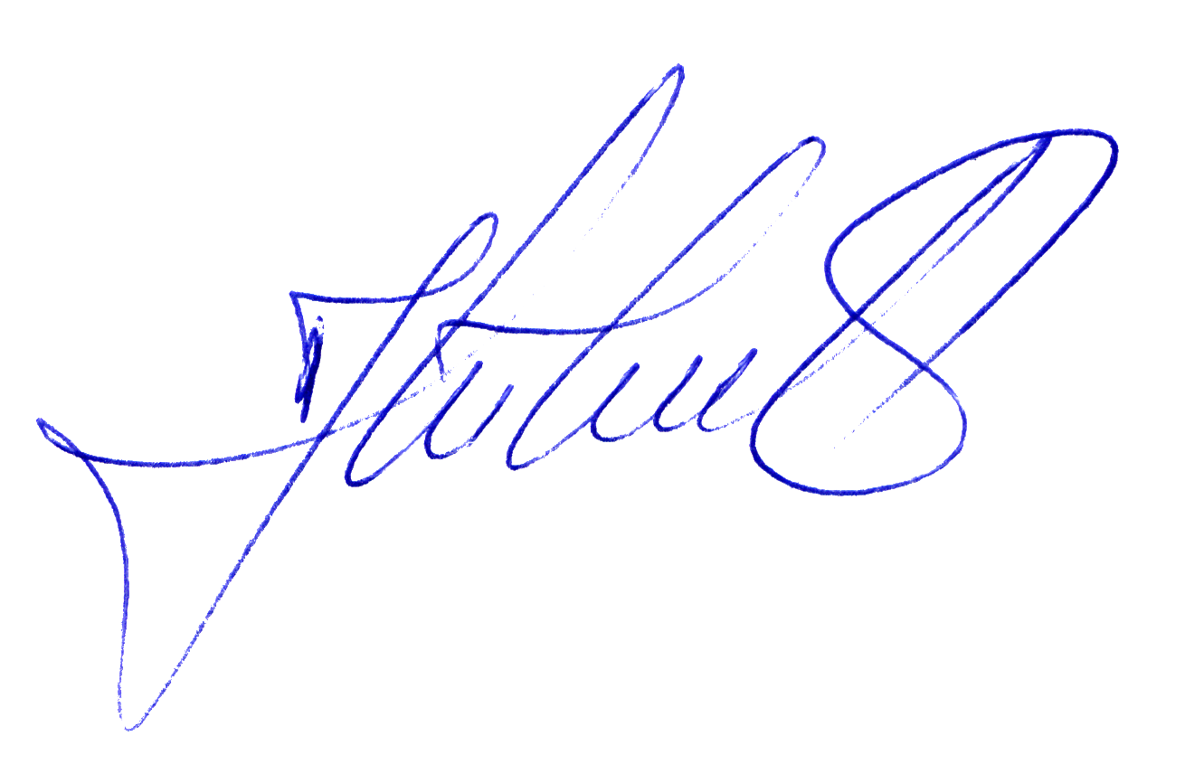
assoc. prof. Milan Banić ________________________________
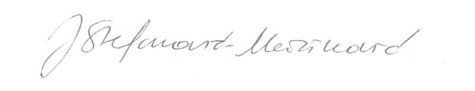
assoc. prof. Jovan Tanasković ________________________________
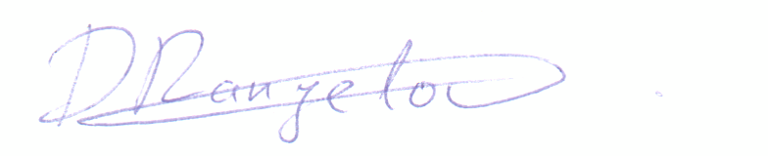
full prof. Jelena Stefanović-Marinović ________________________________
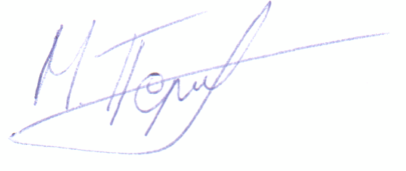
MSc Damjan Rangelov ________________________________
MSc Marko Perić ________________________________

