**Picture 1.** ***CT scan showed subarachnoid hemorrhage***

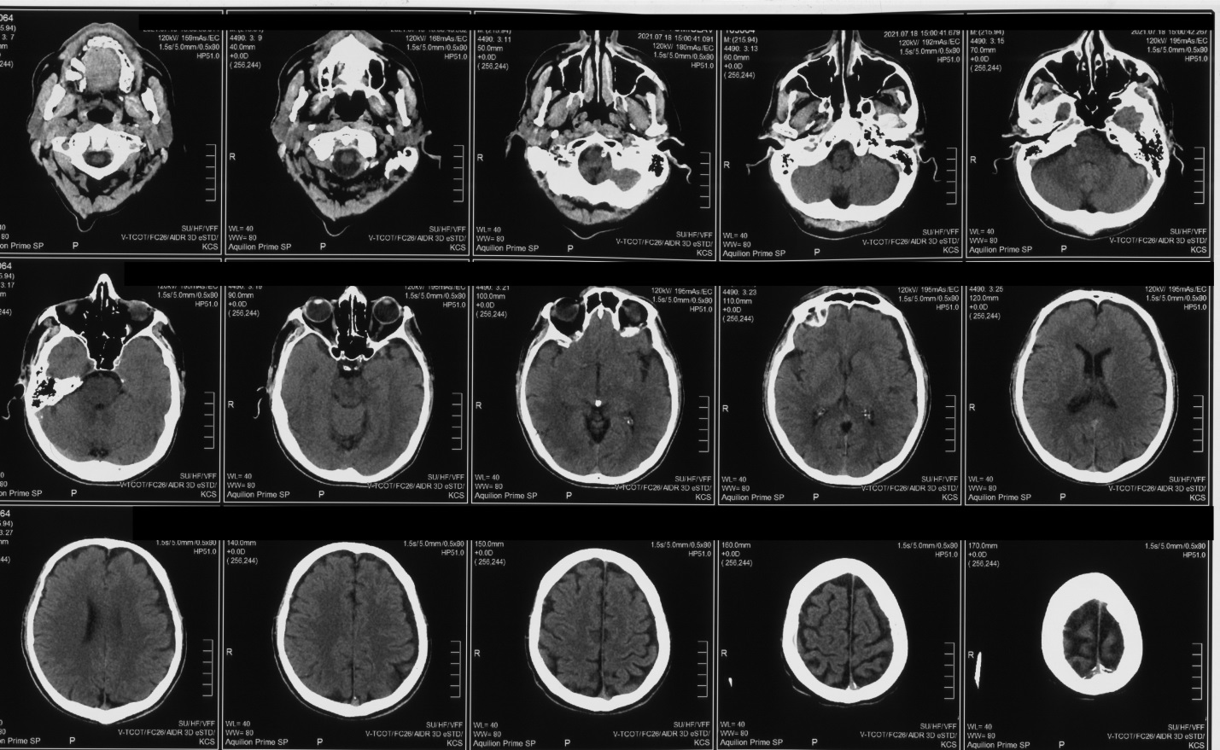

**Picture 2.** ***Angiography showed a saccular aneurysm on the bifurcation of left ACM 7,1x8,7x7,6mm in size***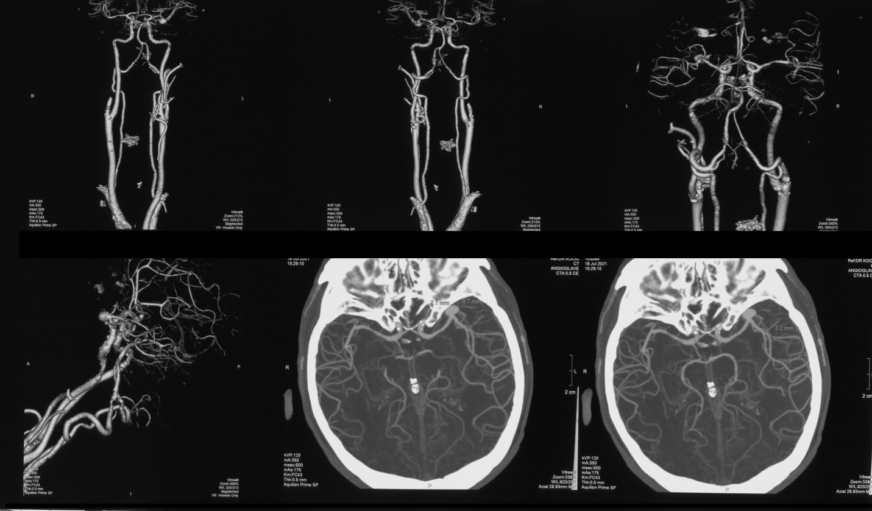

**Picture 3.** ***Aneurysm was embolized with platinum micorspirals (Cosmos 8x25, Cosmos 6x18, Optima soft 4x13)***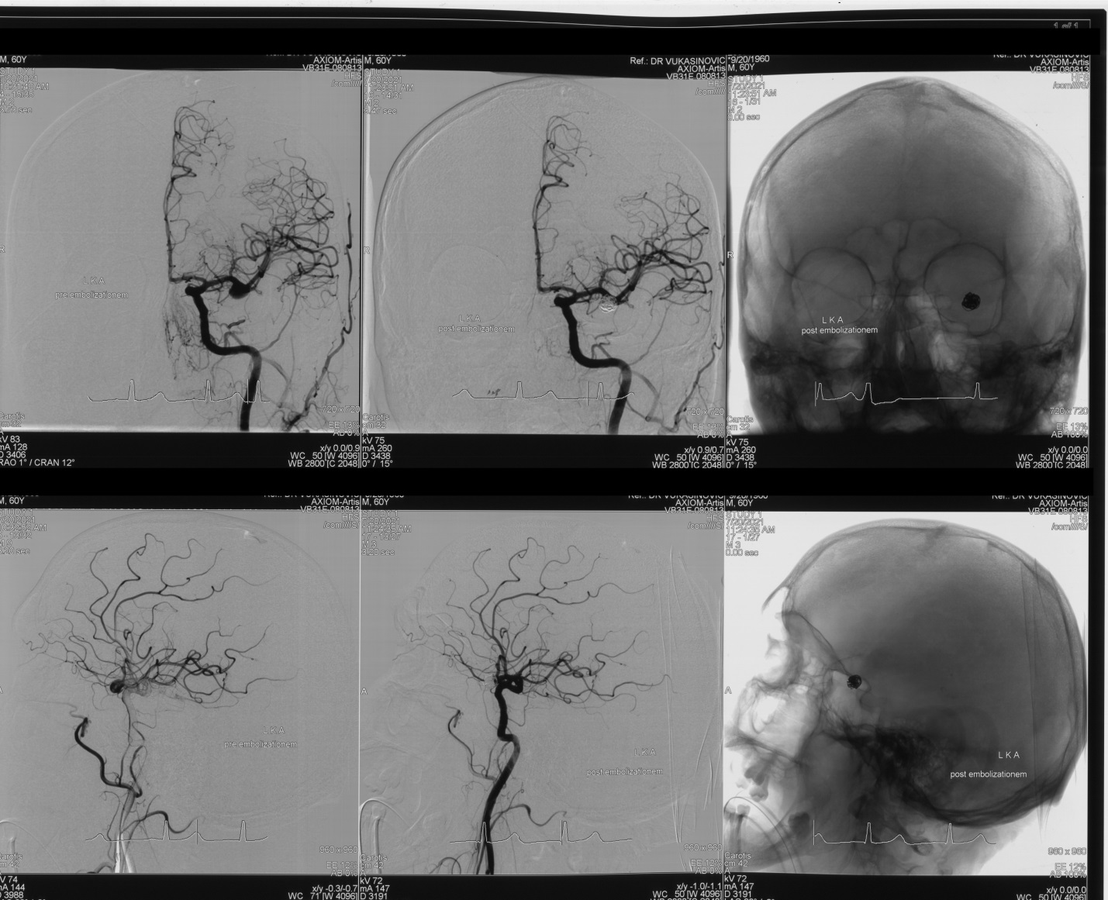

**Picture 4*. Control CT scan showed no signs of rehemorrage, ischemic lesions or hidrocephalus***.

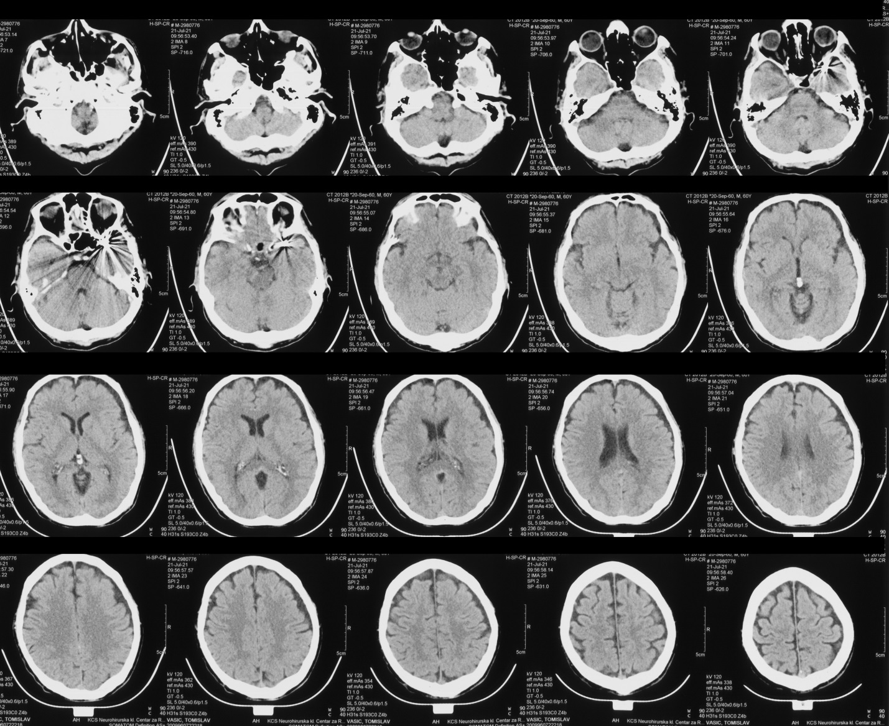

**Picture 5. *There was a compressive hematoma spreading retropharingealy, dimensions 54,3x75,1 mm, ending in the posterior mediastinum i the height of tracheal bifurcation, bilateral pleural effusions with consequential subatalectasis and pericardial effusion, there were no signs of embolism.***

