Letter of Submission
I would like to submit the manuscript entitled
Cystic rectal duplication in children-experience from the small center for consideration for possible publication in Scientific Journal Facta Universitatis, series Medicine and Biology.
The authors of this manuscript have directly participated in the planning, conducting and realization of this study. The authors of paper have read and approved the final version submitted.

We declare that the paper is original, has not been submitted or considered for publication in other journals and has not already been published.

We, the undersigned authors, hereby transfer the copyright to the publisher upon acceptance. Accepted papers become the permanent property of Scientific Journal Facta Universitatis, series Medicine and Biology and may not be reproduced by any means, in whole or in part, without the written consent of the publisher.
It is the author responsibility to obtain permission to reproduce illustrations, tables etc. from other publications.

Yours sincerely,

Ivona Đorđević
Address: Boulevard Dr Zoran Đinđić 46, 18000 Niš, Serbia
Phone:+381 63 81 22 532
Fax:-
E-mail:ivonadj74@gmail.com

Authors/coauthors (name and signature)

Zoran Marjanović
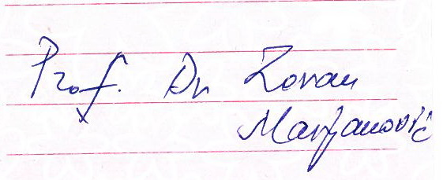

Dragoljub Živanović
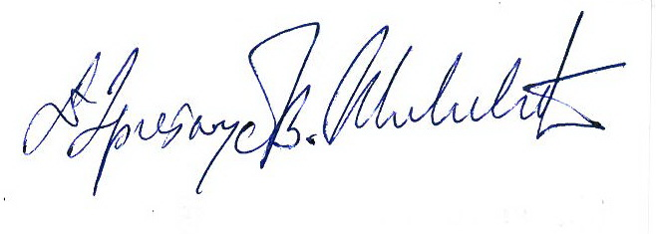
Milan Slavković
