SUPPLEMENTARY MATERIAL TO

Investigation of reaction conditions on synthesis of steroidal bromohydrin
UDC (12pt italic, centered, spacing before 6 pt, spacing after 30 pt,
keep with next)

Ivana Kuzminac¹∗, Olivera Klisurić,² Andrea Nikolić,¹ Marija Sakač¹
¹ Department of Chemistry, Biochemistry and Environmental Protection, Faculty of Sciences, University of Novi Sad, Trg Dositeja Obradovića 3, 21000 Novi Sad, Serbia
² Department of Physics, Faculty of Sciences, University of Novi Sad, Trg Dositeja Obradovića 4, 21000 Novi Sad, Serbia

NMR spectra
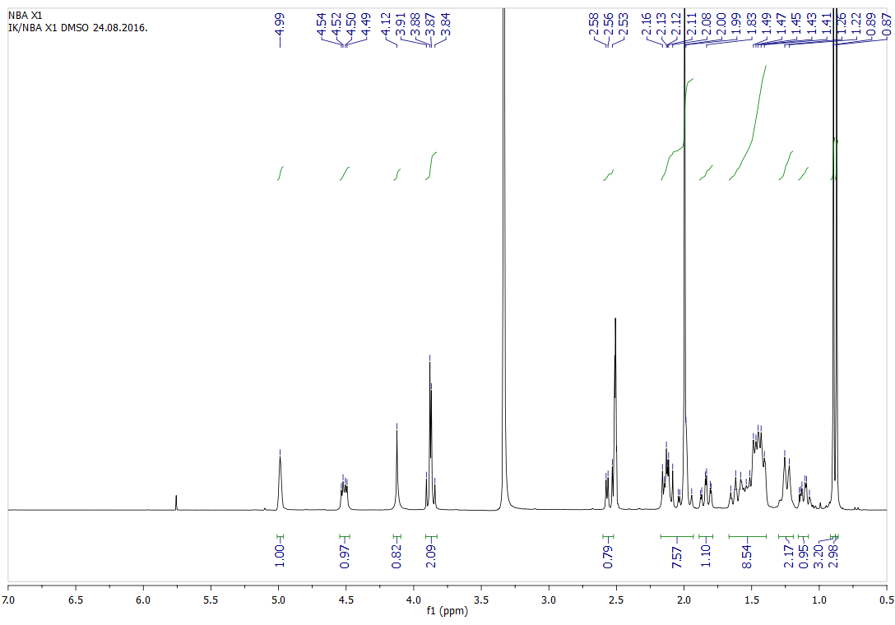
Fig. 1 ¹H NMR spectrum of compound 5

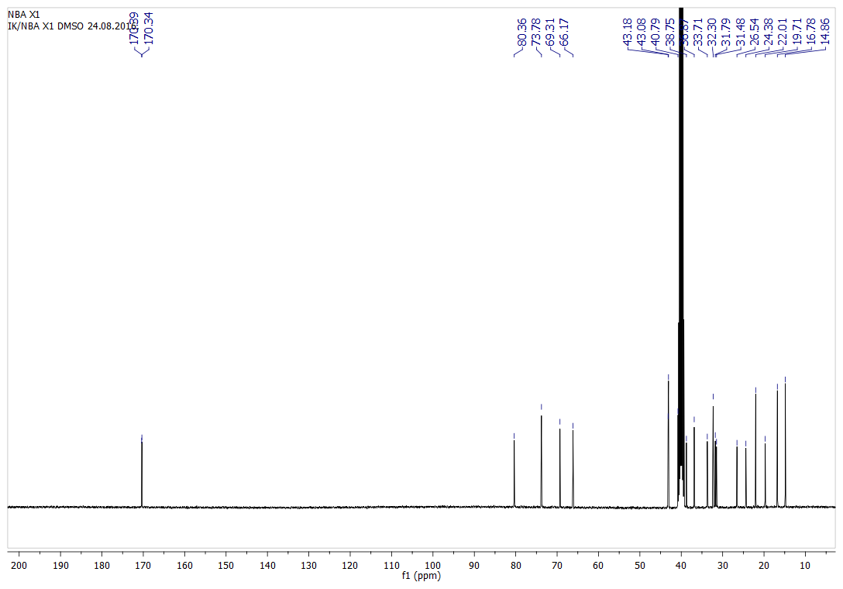
Fig. 2 ¹³C NMR spectrum of compound 5

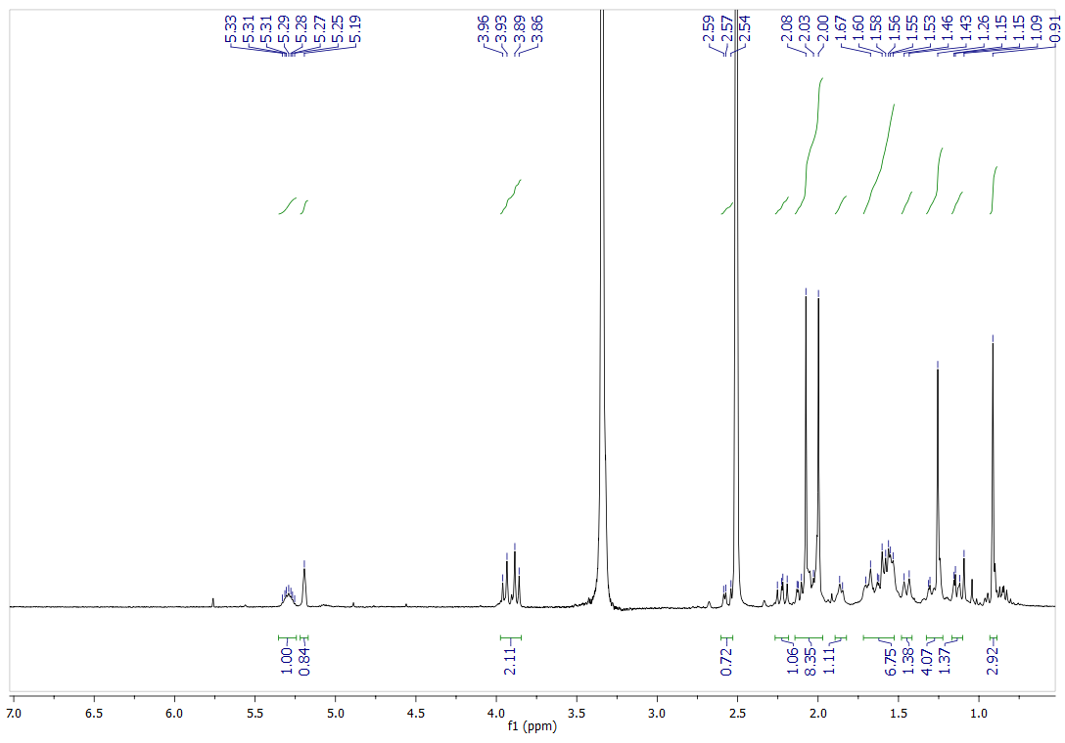
Fig. 3 ¹H NMR spectrum of compound 6

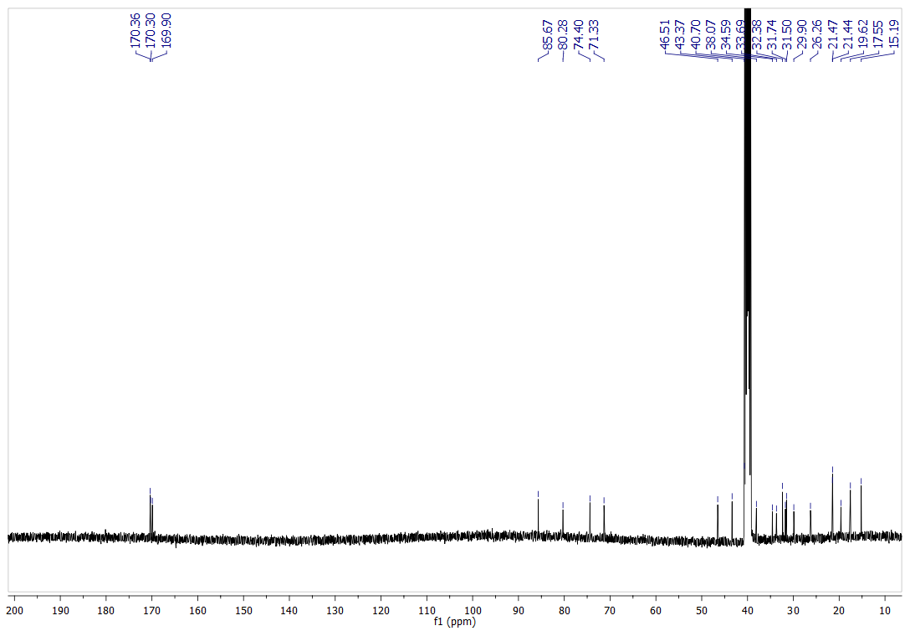
Fig. 4 ¹³C NMR spectrum of compound 6

 Contacts of Corresponding author: E-mail: ivana.kuzminac@dh.uns.ac.rs; Tel: +381 21 485 2774

