Table 1 Body composition parameters
N=66 | Minimum | Maximum | Mean | Std.Deviation
Hight | 151.00 | 198.00 | 175.09 | 9.20
Bodyweight | 37.10 | 86.70 | 64.47 | 10.94
Skeletal Muscle Mass | 18.60 | 45.20 | 32.40 | 5.86
Body Fat Mass | 1.80 | 24.60 | 7.09 | 3.59
Body Mass Index | 15.00 | 25.80 | 20.91 | 2.24
Right Leg Lean Mass | 5.34 | 13.68 | 9.16 | 1.61
Left Leg Lean Mass | 5.32 | 13.55 | 9.09 | 1.60
Right+Left Leg Lean Mass | 10.66 | 27.23 | 18.25 | 3.21
Intracellural Water Mass | 15.80 | 36.20 | 26.38 | 4.49
Extracellural Water Mass | 9.50 | 21.60 | 15.68 | 2.49
Protein Mass | 6.80 | 15.60 | 11.40 | 1.94
Mineral Mass | 2.42 | 5.34 | 3.93 | 0.67

Fig. 1 Body parameters by age group (p<0.05)
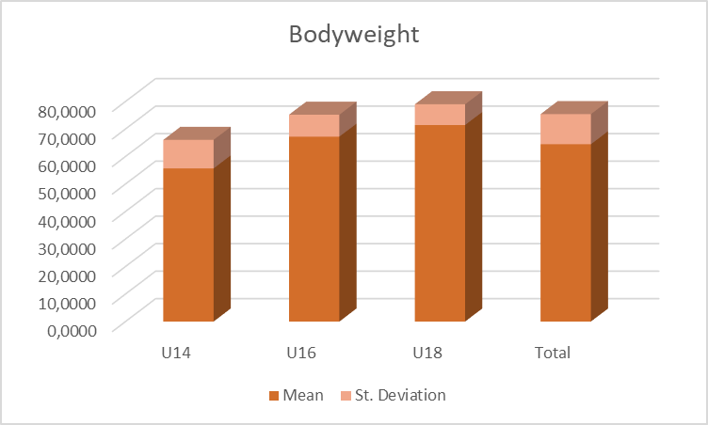
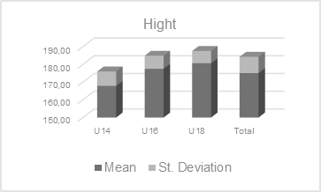
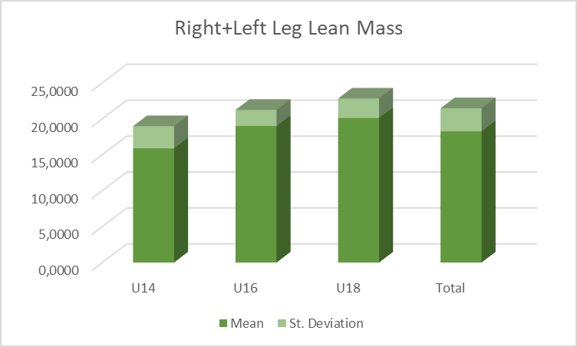
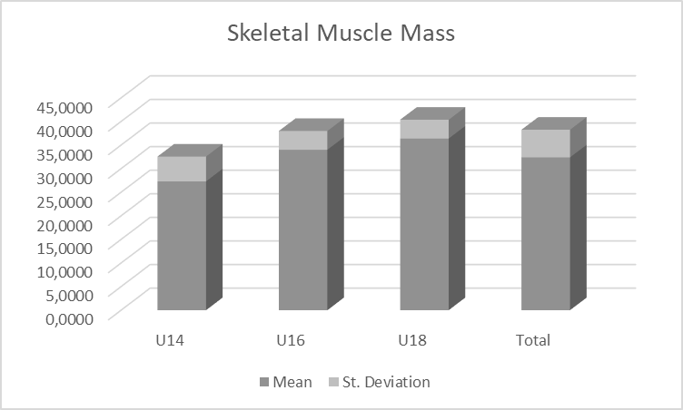
Agility without the ball (AWOB) - defense
Illinois test without the ball
TDS Dribbling Test without the ball
T-Test.
Agility with the ball (AWB) - attack
Illinois Test with ball drilling on arbitrary side
TDS Dribbling Test with dominant leg
TDS Dribbling Test with subdominant leg.

r=0.595p<0.000

Fig. 2 AWOB and AWB
Table 2 Correlation between agility indicators and body composition (Pearson)
 | Hight | Weight | SMM | BFM | BMI
AWOB | -,318** | -,329** | -,453** | ,143 | -,276*
AWB | -,167 | -,217 | -,263* | ,007 | -,245*
CAG | -,244* | -,283* | -,365** | ,060 | -,283*

 | IWM | EWM | PM | MM | R+LLLM
AWOB | -,454** | -,374** | -,453** | -,417** | -,331**
AWB | -,264* | -,216 | -,263* | -,253* | -,166
CAG | -,366** | -,301* | -,365** | -,344** | -,248*
**. Correlation is significant at the 0.01 level (2-tailed).
*. Correlation is significant at the 0.05 level (2-tailed).

Legend of abbreviations.
AWOB. agility without the ball
AWB. agility with the ball
CAG. combined agility
SMM. Skeletal Muscle
BFM. Body Fat Mass
BMI. Body Mass Index
IWM. Intracellular Water Mass
EWM. Extracellular Water Mass
PM. Protein Mass
MM. Mineral Mass
RLLM. Right Leg Lean Mass
LLLM. Left Leg Lean Mass

Table 3 Laterality
Right Dominant LegN=56 | LLLM | RLLM | AWOB | AWB | CAG
LLLM | 1 | ,998** | -,353** | -,159 | -,255
RLLM | ,998** | 1 | -,353** | -,158 | -,255
AWOB | -,353** | -,353** | 1 | ,586** | ,819**
AWB | -,159 | -,158 | ,586** | 1 | ,945**
CAG | -,255 | -,255 | ,819** | ,945** | 1
**. Correlation is significant at the 0.01 level (2-tailed).

Left Dominant Leg  N=10 | LLLM | RLLM | AWOB | AWB | CAG
LLLM | 1 | ,999** | ,009 | -,211 | -,168
RLLM | ,999** | 1 | -,011 | -,246 | -,201
AWOB | ,009 | -,011 | 1 | ,730* | ,833**
AWB | -,211 | -,246 | ,730* | 1 | ,986**
CAG | -,168 | -,201 | ,833** | ,986** | 1
**. Correlation is significant at the 0.01 level (2-tailed).
*. Correlation is significant at the 0.05 level (2-tailed).

Legend of abbreviations.
RLLM. Right Leg Lean Mass
LLLM. Left Leg Lean Mass
AWOB. agility without the ball
AWB. agility with the ball
CAG. combined agility

